Index of Multiple Deprivation (IMD) 2025

This report provides a briefing on the 2025 release of the Index of Multiple Deprivation on 30 October 2025; what it is, how it can be used and what it means for Bury.
Contents

Introduction 2
The Indices of Deprivation (IoD) and the Index of Multiple Deprivation (IMD) 4
How the Index of Multiple Deprivation is Used 4
Domains of Deprivation 6
Change in number of LADs and LSOAs between Indices iterations 7
Deprivation in Bury 7
How Bury compares to all Local Authority Districts (2025) 9
Clinical Commissioning Groups (Bury) – Integrated Care Boards (GM) 11
Wards and Neighbourhoods 11
LSOA level 11
Change from 2019 13
Domains of deprivation 14
Domains of deprivation – Bury’s ranks 26
Supplementary indices of the Income Deprivation Domain 27
Further information 31
Contact 31

Introduction
The English Indices of Deprivation 2025 (IoD25) provide a set of relative measures of deprivation for small areas (Lower-layer Super Output Areas) across England, based on seven different domains of deprivation:
• Income Deprivation
• Employment Deprivation
• Education, Skills and Training Deprivation
• Health Deprivation and Disability
• Crime
• Barriers to Housing and Services
• Living Environment Deprivation
Each of these domains is based on a set of indicators. Each indicator is based on data from the most recent time point available on a consistent basis across neighbourhoods in England. Overall, a total of 55 indicators comprise the IoD25, an increase from 39 in the IoD19. Of these, 20 are new indicators, 14 indicators have been significantly modified, while 21 have been updated to more recent timepoints. Three indicators have also been removed. A detailed breakdown of the changes can be found in the Technical Report.
The Index of Multiple Deprivation 2025 (IMD 2025) combines information from the seven domains to produce an overall relative measure of deprivation. In addition, there are seven domain-level Indices, and two supplementary Indices; Income Deprivation Affecting Children Index and the Income Deprivation Affecting Older People Index. The Indices of Deprivation are designed primarily to be small-area measures of relative deprivation. But the Indices are commonly used to describe relative deprivation for higher-level geographies. To facilitate this, a range of summary measures are available for higher-level geographies: Local Authority Districts and upper tier Local Authorities, Local Enterprise Partnerships and Integrated Care Boards (ICBs). These summary measures are produced for the overall Index of Multiple Deprivation, each of the seven domains and the supplementary Indices.
The IoD25 can be used to compare small areas across England, identify the most deprived small areas, explore the domains (or types) of deprivation, compare larger administrative areas e.g. local authorities and look at changes in relative deprivation between iterations (i.e. changes in ranks).
The IoD25 cannot be used to quantify how deprived a neighbourhood is, identify deprived people or levels of affluence, compare small areas in other UK countries or measure absolute change in deprivation over time.
The Indices of Deprivation including the Index of Multiple Deprivation (IMD) are commissioned by the Ministry of Housing, Communities and Local Government (MHCLG) and are produced by Oxford Consultants for Social Inclusion (OCSI).
The IoD25 uses LSOAs from the 2021 Census to measure deprivation at a small area or neighbourhood level. LSOAs are produced by the Office of National Statistics (ONS) with each Census and are a standard statistical geography used for reporting small area statistics. They are designed to be consistent, accounting for a similar population size across the country – on average 1,500 residents or 650 households – and all types of geographic area (urban, rural, coastal, island or otherwise) in the same way. There are 33,755 LSOAs in England, and the rankings are:
- 1st is the most deprived area
- 33,755th is the least deprived area.
The IMD25 ranks all neighbourhoods in England according to their level of multiple deprivation relative to that of other areas. High ranking LSOAs or neighbourhoods can be referred to as the ‘most deprived’ or as being ‘highly deprived’ to aid interpretation. However, there is no definitive threshold above which an area is described as ‘deprived’. Across the IoD25, deprivation is measured on a relative rather than an absolute scale, so a neighbourhood ranked 100th is more deprived than a neighbourhood ranked 200th, but this does not mean it is twice as deprived. The scores for the IMD are less easy to interpret, as they do not relate straightforwardly to the proportion of the population experiencing deprivation. It is recommended that ranks and deciles, but not scores, are used in the case of the IMD. More information can be found in the Research Report.
Although the IMD is designed to be used for small areas (LSOAs), ranks are also published for other geographies, including Local Authorities and ICBs.

At the neighbourhood-level, the IoD25 provides a place-based insight into deprivation. However, this description does not apply to every person living in these areas. Many non-deprived people live in deprived areas, and many deprived people live in non-deprived areas. It is important to note that the IoD25 is designed to identify and measure specific aspects of deprivation, rather than measures of affluence. This means that differences between the least deprived areas in the country are less well defined than differences between the more deprived areas.
This release focuses on headline findings from the IoD25 concentrating on neighbourhood and Local Authority District (LAD) patterns of deprivation across England. These are reported across domains using a range of summary measures to help facilitate a broader understanding of deprivation.
- Overall, 82% of neighbourhoods that are in the most deprived decile according to the IMD25 were also the most deprived according to the IMD19.
- Deprivation is dispersed across England - 65% of Local Authority Districts contain at least one of the most deprived neighbourhoods in England.
The purpose of the Indices is to provide a consistent, accurate and robust measure of relative deprivation at a small area level across England. Updates and changes to methods and datasets come at the expense of ‘backwards’ comparability with previous versions of the Indices. Indices releases should not be viewed or construed as a time-series and there are other important changes to consider which limit the ability to make accurate comparisons over time:

- changes to the data used to construct the indicators, including changes to eligibility criteria for certain benefits, definitions and collection methods alongside the removal or inclusion of new datasets
- updates and revisions to population denominator data
- changes to the area definitions and administrative geographies

However, keeping a consistent conceptual framework and methodology does allow some comparisons to be made, but only in terms of comparing the rankings as a snapshot in time, accompanied by appropriate caveats around changes as noted above.
A Research Report provides guidance on how to use and interpret the datasets and presents further results from the IoD25. It includes a full account of the set of summary statistics available for higher-level geographies such as Local Authority Districts, with an example of their use, and advice on interpreting change over time.

The Indices, along with guidance and FAQs (from which some of the text below is taken) can be found here: https://www.gov.uk/government/statistics/english-indices-of-deprivation-2025

The Indices of Deprivation (IoD) and the Index of Multiple Deprivation (IMD)
The Indices of Deprivation 2025 provide a set of relative measures of deprivation for small areas (Lower-layer Super Output Areas, or ‘LSOA’s) across England, based on seven different domains of deprivation. These domains are then combined to produce an overall relative measure of deprivation – the Index of Multiple Deprivation (IMD). The domains are combined using the following weights:

- Income Deprivation (22.5%)
- Employment Deprivation (22.5%)
- Education, Skills and Training Deprivation (13.5%)
- Health Deprivation and Disability (13.5%)
- Crime (9.3%)
- Barriers to Housing and Services (9.3%)
- Living Environment Deprivation (9.3%)

For more information on what each domain includes, please see the relevant section below. Each domain has its own index which has been analysed separately, and there are supplementary indices available for Income Deprivation Affecting Children (IDACI) and Income Deprivation Affecting Older People (IDAOPI).
There are 33,755 LSOAs in England and each has been ranked according to their deprivation score (1 = most deprived) and then divided into 10 equal groups (deciles). These deciles range from the most deprived 10% of neighbourhoods nationally to the least deprived 10% of neighbourhoods nationally.

How the Index of Multiple Deprivation is Used
Since their original publication in 2000, the Indices have been used very widely for a variety of purposes, including the following:

General uses:
- The Indices are an important tool used by national and local organisations to target resources, develop policy and support decisions about addressing local needs.
- The Indices are frequently used in bids for funding, and are recognised by commissioners as an authoritative, nationally comparable measure of deprivation. This includes bids made by councillors for their neighbourhoods, and from voluntary and community sector groups.
- The Indices are also used to assess programme reach and impact e.g. to identify whether the most disadvantaged areas are receiving more support under various programmes than others; and in assessment of the impact of programmes, albeit at the neighbourhood rather than the individual level.

More specific uses:
- The Indices are drawn on extensively in administering Local Government support and future service planning.
- The Indices have been used in assessing resources and demand for policing across England by the Home Office.
- The IDACI data is an integral part of both the schools and high need funding formulae administered by the Department for Education. IDACI data is used as a proxy for deprivation in the Schools National Funding Formula (NFF) and in the High Needs National Funding Formula (HNNFF).
- The Indices were, and continue to be, drawn on heavily by the Office for National Statistics (ONS) regarding a range of pandemic related analysis.
- Office for Health Improvement and Disparities (OHID) has used the Indices to produce indicators for the Government’s Public Health Outcomes Framework (PHOF) examining recent trends in inequalities in life expectancy and healthy life expectancy between communities. OHID has also used the Indices to illustrate inequalities in many of the other PHOF indicators, and users of the PHOF tool can now examine the relationship of every indicator with deprivation.

Domains of Deprivation
The following infographic summarises the English IoD2025.
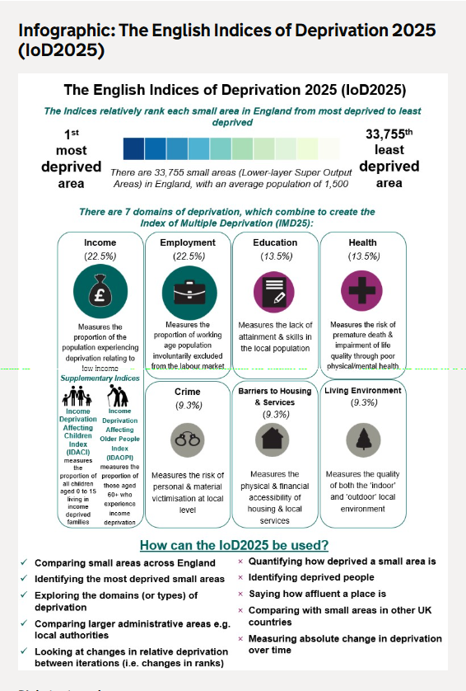

Change in number of LADs and LSOAs between Indices iterations
LSOAs form the building blocks of all higher-level geography summaries of the Indices. However, both statistical and administrative geographies have changed over time. Specifically, the number of LSOAs and Local Authority Districts in England has changed since the IoD2019 and previous iterations (see table below). This makes comparison over time more problematic, given the additional changes to population estimates, new datasets and enhancements since the previous release.

Indices Iteration | Number of Local Authority Districts (LAD) | Number of LSOAs
IoD2025 | 296 | 33,755
IoD2019 | 317 | 32,844
IoD2015 | 326 | 32,844
IoD2010 | 326 | 32,482
IoD2007 | 354 | 32,482
IoD2004 | 354 | 32,482

Deprivation in Bury
Although the IMD is designed to be used for small areas (LSOAs), ranks are also published for other geographies, including Local Authorities and ICBs.

Bury is ranked 90 out of 296 Local Authorities (where 1 is the most deprived).

In 2019, Bury was ranked 95 out of 317 Local Authorities (where 1 is the most deprived).

In 2015, Bury was ranked 122 out of 326 Local Authorities (where 1 is the most deprived).

The changes from 2015 to 2019 and to 2025 appear to represent an increase in relative deprivation in Bury. However, this must be considered in the context that there has been a decrease in the number of LAs due to structural reorganisation such as the merger of county and district councils into unitary authorities.

Bury is the 8th most deprived of the 10 GM districts (where 1st is the most deprived). There has been no change in GM ranking from 2015 to 2019 to 2025.

Amongst our NHSE Statistical Neighbours, Bury is ranked 8th out of 16 (where 1st is the most deprived), in 2025.

Amongst our CIPFA Statistical Neighbours in 2019, Bury was ranked 14th out of 16 (where 1st is the most deprived), making it the 3rd least deprived.

Although Bury’s rank amongst its statistical neighbours appears to show an increase in relative deprivation when compared to 2019 this is due to a change in the statistical neighbours, as we are now comparing Bury to NHSE neighbours, not CIPFA neighbours as previously. This is in line with other GM authorities.

The above IMD calculations are based upon rank of average IMD score, following a GM wide adoption of methodology. The below maps show the IMD 2025 for all LSOAs in Bury, where darker shading indicates a higher level of deprivation.

IMD 2025 deciles for LSOAs in Bury

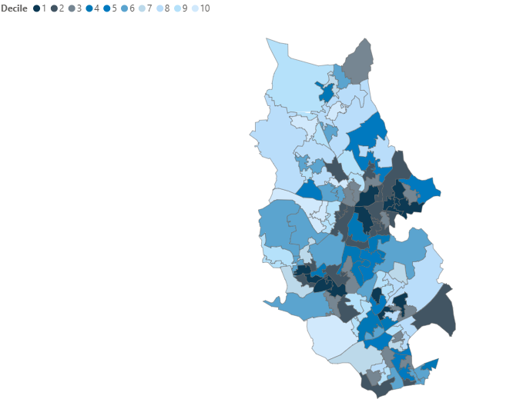

IMD 2025 ranks for LSOAs in Bury

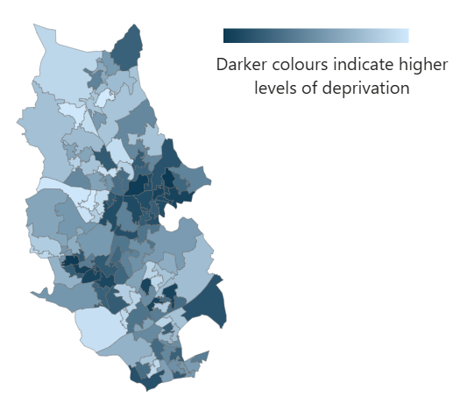

How Bury compares to all Local Authority Districts (2025)
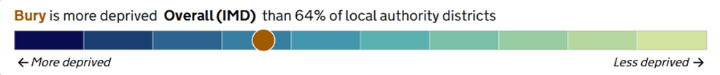

Local Deprivation Explorer - Home

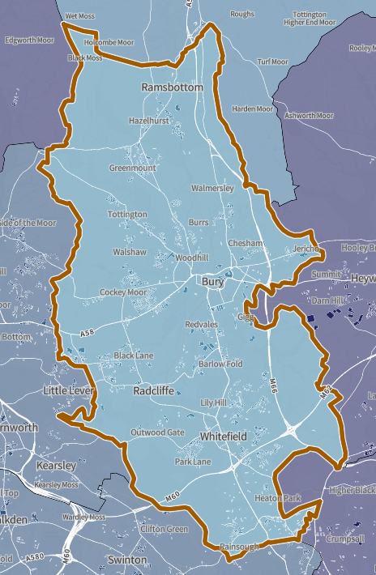
The following chart, from LG Inform, shows Bury’s overall IMD 2025 ranking amongst all local authorities in the North West
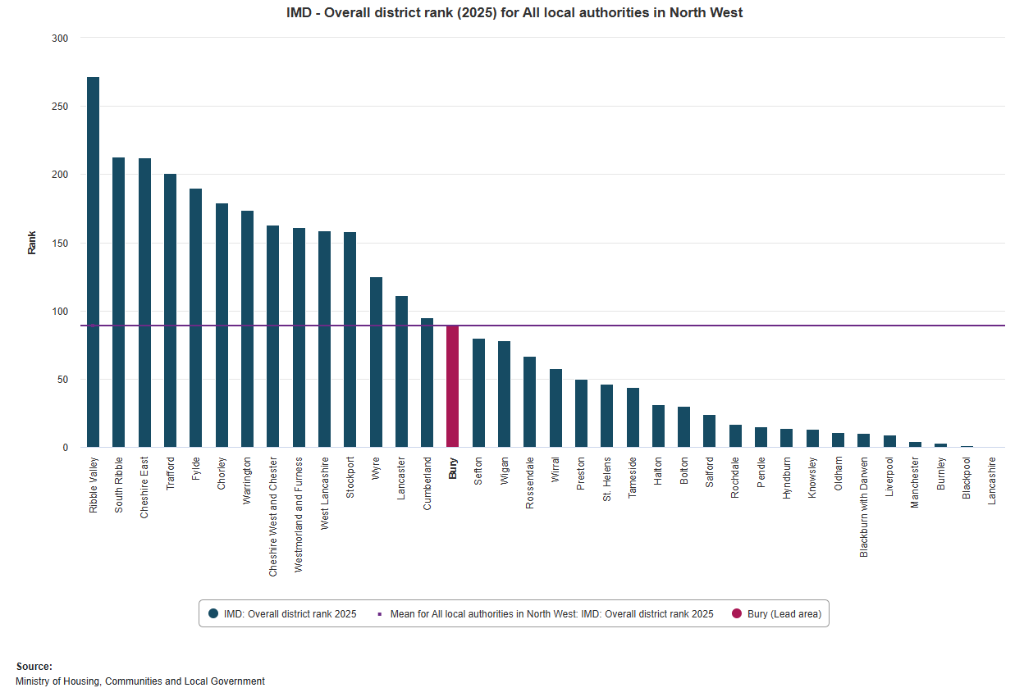

Clinical Commissioning Groups (Bury) – Integrated Care Boards (GM)
In 2019, Bury ranked 72 of the 191 Clinical Commissioning Groups in England for deprivation (where 1 is the most deprived). The GM CCGs have been replaced by NHS Greater Manchester, which in 2025 is ranked 3rd of the 42 Integrated Care Boards (ICBs) in England for deprivation (where 1 is the most deprived), so this cannot be compared to the previous Bury CCG ranking from 2019.

Wards and Neighbourhoods
The deprivation scores are designed to be used at small-area level (LSOA) and are not currently published at ward or neighbourhood level. Wards are much larger than LSOAs, vary greatly in size across the country and are prone to regular boundary changes, making them unsuitable as a unit of analysis or for identifying pockets of deprivation.

LSOA level
There are 120 LSOAs in Bury, and each has been ranked according to its deprivation score and grouped into national deciles (ten groups ranging from ‘10% most deprived’ to ‘10% least deprived’ in England).
A map of the LSOAs in Bury showing their national deprivation decile can be seen below (source MCHLG):
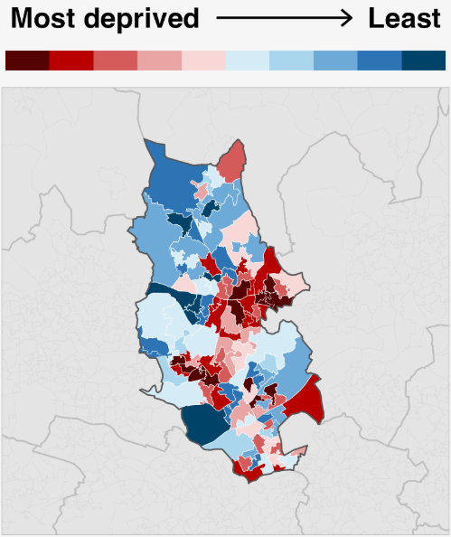

A map of the LSOAs in Bury showing their deprivation rank can be seen below (source Local Insight):
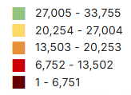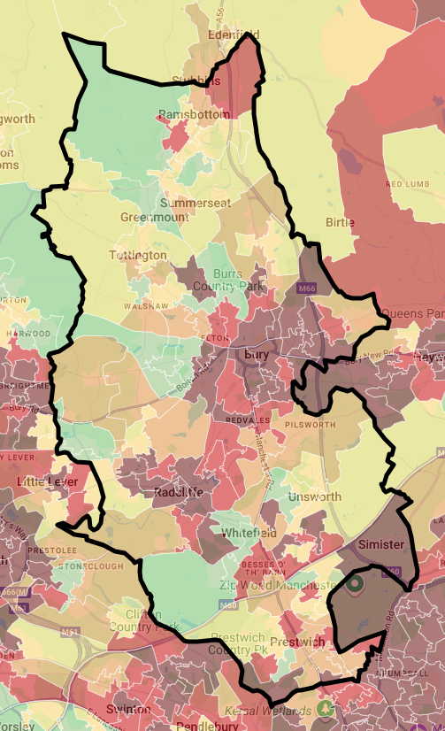

There are 13 LSOAs in Bury that are in the 10% most deprived in the country (shown in dark red on the map above). These are mostly found in East, Radcliffe, Besses and Moorside areas.

The below table shows the 13 most deprived LSOAs in Bury according to where they rank in comparison to all 33,755 LSOAs in England for the Index of Multiple Deprivation (IMD) for 2025. Those shaded in dark blue are the LSOAs that have remained in the top 10% most deprived in the country from the 2019 IMD.

LSOA name | LSOA description | Ward | Rank
Bury 007E | Chesham Fold | Moorside | 82
Bury 016C | Radcliffe Boro FC/Coronation Road | Radcliffe North and Ainsworth | 200
Bury 008C | Fernhill | Moorside | 654
Bury 016B | Radcliffe Cricket Club/Water Street | Radcliffe West | 1435
Bury 008A | Villier Street/Percy Street/Pine Street | Bury East | 1766
Bury 016D | Civic Centre/Town Hall/Victoria Street | Radcliffe West | 1913
Bury 021E | Mersey Drive | Besses | 1932
Bury 007D | Teak Street/Hazel Avenue/Craven Street/Renshaw Drive/Bridgefield Drive | Bury East | 1974
Bury 020C | Elms North | Unsworth | 2110
Bury 021B | Moss Lane/Ribble Drive | Besses | 2290
Bury 016E | Coronation Park/Town Centre | Radcliffe East | 2689
Bury 008B | Willow Street | Bury East | 3070
Bury 011B | Bolton Street/Millet Street/Manchester Road/Richmond Street/Bury Interchange | Redvales | 3156

The below table shows the 12 most deprived LSOAs in Bury according to where they rank in comparison to all 32,844 LSOAs in England for the Index of Multiple Deprivation (IMD) for 2019. Those shaded in dark blue are the LSOAs that have remained in the top 10% most deprived in the country for the IMD 2025.

LSOA name | LSOA description | Ward | Rank
Bury 007E | Chesham Fold | Moorside | 50
Bury 016C | Radcliffe Boro FC/Coronation Road | Radcliffe North and Ainsworth | 372
Bury 007D | Teak Street/Hazel Avenue/Craven Street/Renshaw Drive/Bridgefield Drive | Bury East | 734
Bury 008C | Fernhill | Moorside | 1,177
Bury 008E | Pimhole Rd/South Cross St/Cecil Street/The Rock/Bus Depot/Market | Bury East | 1,199
Bury 020C | Elms North | Unsworth | 1,200
Bury 021E | Mersey Drive | Besses | 1,478
Bury 016B | Radcliffe Cricket Club/Water Street | Radcliffe West | 1,742
Bury 008A | Villier Street/Percy Street/Pine Street | Bury East | 1,891
Bury 021B | Moss Lane/Ribble Drive | Besses | 2,065
Bury 016E | Coronation Park/Town Centre | Radcliffe East | 2,114
Bury 009B | Daisyfield | Bury West | 2,599

Change from 2019
The majority of Bury LSOAs have seen minimal change in their relative deprivation rank since 2019. There is an overall increase of one additional LSOA in 2025, from 12 to 13, that falls within the most deprived 10% in the country. Two LSOAs have moved from the most to second-most deprived decile, and three have moved from the second-most to most deprived decile.

The three LSOAs in Bury that have moved from the second-most to most deprived are:

- Bury 008B - Willow St (Bury East)
- Bury 011B - Bolton St/Millet St/Manchester Rd/Richmond St/Bury Interchange (Redvales)
- Bury 016D - Civic Centre/Town Hall/Victoria Street (Radcliffe West)

The two LSOAs in Bury that have moved from the most to second-most deprived are:

- Bury 008E - Pimhole Rd/South Cross St/Cecil Street/The Rock/Bus Depot/Market (Bury East)
- Bury 009B - Daisyfield (Bury West)

Looking at the GM Local Authorities (LAs), five have seen worsening rankings since 2019, indicating higher levels of deprivation relative to other LAs nationally (although again considering the reduction in the overall number of LAs). The five LAs that have seen worsening rankings are Bolton, Bury, Manchester, Oldham and Rochdale.

Domains of deprivation
There are seven domains of deprivation.
Income Deprivation Domain
The Income Deprivation Domain measures the proportion of the population experiencing deprivation relating to low income. The definition of income deprivation used here includes people who are dependent upon the state for some form of means-tested benefit, and includes both those people that are out-of-work, and those that are in work but who have low earnings and are claiming a means tested benefit. In addition, an Income Deprivation Affecting Children Index (IDACI) and an Income Deprivation Affecting Older People Index (IDAOPI) were created, respectively representing the proportion of children aged 0-15 years old, and people aged 60 and over, living in income deprived households. There two supplementary indices are in the sub-set of this domain and are detailed separately below.
Bury has seen improved relative deprivation for Income Deprivation - moving 5 places from rank 83 in 2019 to rank 88 in 2025.
The below maps show the Income Deprivation Domain for all LSOAs in Bury in 2025, where darker shading indicates a higher level of deprivation.
Income Deprivation Domain Deciles for LSOAs in Bury
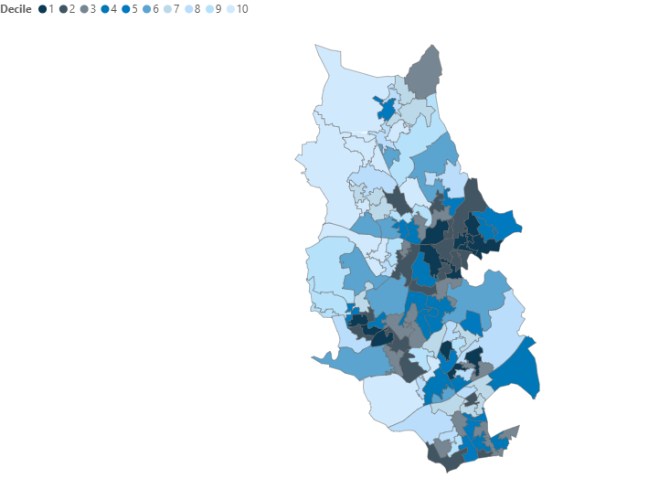

Income Deprivation Domain Ranks for LSOAs in Bury
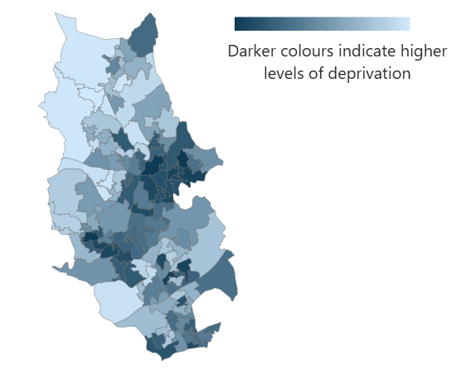

The below table shows the 10 most deprived LSOAs in Bury according to where they rank in comparison to all 33,755 LSOAs in England for the Income Deprivation Domain for 2025.

LSOA name | LSOA description | Ward | Rank
Bury 007E | Chesham Fold | Moorside | 93
Bury 008C | Fernhill | Moorside | 425
Bury 016C | Radcliffe Boro FC/Coronation Road | Radcliffe North and Ainsworth | 683
Bury 021B | Moss Lane/Ribble Drive | Besses | 1459
Bury 008A | Villier Street/Percy Street/Pine Street | Bury East | 1784
Bury 007D | Teak Street/Hazel Avenue/Craven Street/Renshaw Drive/Bridgefield Drive | Bury East | 1786
Bury 021E | Mersey Drive | Besses | 2044
Bury 016D | Civic Centre/Town Hall/Victoria Street | Radcliffe West | 2721
Bury 016B | Radcliffe Cricket Club/Water Street | Radcliffe West | 2741
Bury 011C | Springs - Townside Row/Killon Street/Alfred Street/Hampshire Close/Gigg Lane/Somerset Drive | Redvales | 2797

Employment Deprivation Domain
The Employment Deprivation Domain measures the proportion of the working age population involuntarily excluded from the labour market. This includes people who may want to work but are unable to do so due to unemployment, sickness or disability, or caring responsibilities.
Bury has seen improved relative deprivation for Employment Deprivation - moving 14 places from rank 57 in 2019 to rank 71 in 2025.
The below maps show the Employment Deprivation Domain for all LSOAs in Bury in 2025, where darker shading indicates a higher level of deprivation.
Employment Deprivation Domain Deciles for LSOAs in Bury

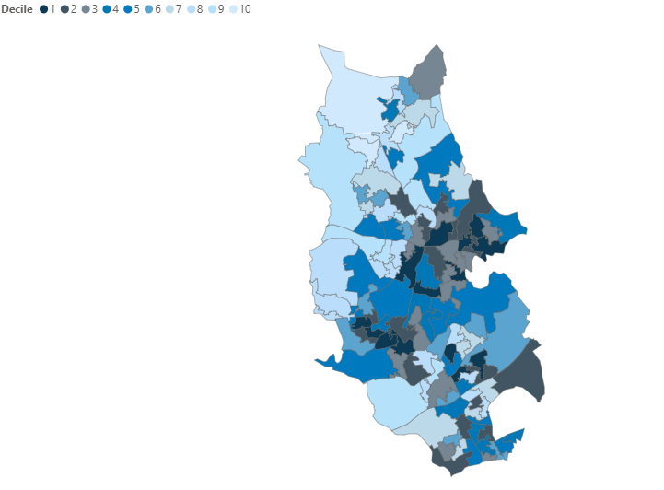

Employment Deprivation Domain Ranks for LSOAs in Bury
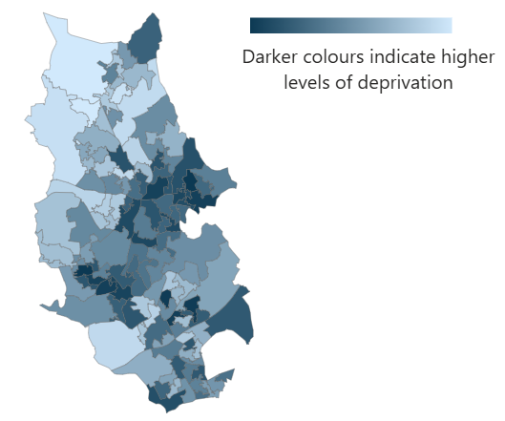

The below table shows the 10 most deprived LSOAs in Bury according to where they rank in comparison to all 33,755 LSOAs in England for the Employment Deprivation Domain for 2025.

LSOA name | LSOA description | Ward | Rank
Bury 016C | Radcliffe Boro FC/Coronation Road | Radcliffe North and Ainsworth | 89
Bury 007E | Chesham Fold | Moorside | 98
Bury 020C | Elms North | Unsworth | 668
Bury 021E | Mersey Drive | Besses | 714
Bury 021B | Moss Lane/Ribble Drive | Besses | 1247
Bury 007D | Teak Street/Hazel Avenue/Craven Street/Renshaw Drive/Bridgefield Drive | Bury East | 1315
Bury 016D | Civic Centre/Town Hall/Victoria Street | Radcliffe West | 1428
Bury 008C | Fernhill | Moorside | 1629
Bury 016B | Radcliffe Cricket Club/Water Street | Radcliffe West | 1649
Bury 016E | Coronation Park/Town Centre | Radcliffe East | 2053

Education, Skills and Training Deprivation Domain
The Education, Skills and Training Deprivation Domain measures the lack of attainment and skills in the local population. The indicators fall into two sub-domains: one relating to children and young people and one relating to adult skills. These two sub-domains are designed to reflect the ‘flow’ and ‘stock’ of educational disadvantage within an area respectively. That is, the ‘children and young people’ sub-domain measures the attainment of qualifications and associated measures (‘flow’), while the ‘skills’ sub-domain measures the lack of qualifications in the resident working age adult population (‘stock’).
Bury has seen worsening relative deprivation for Education, Skills and Training Deprivation - moving 25 places from rank 164 in 2019 to rank 139 in 2025.
The below maps show the Education, Skills and Training Deprivation Domain for all LSOAs in Bury in 2025, where darker shading indicates a higher level of deprivation.

Education, Skills and Training Deprivation Domain Deciles for LSOAs in Bury
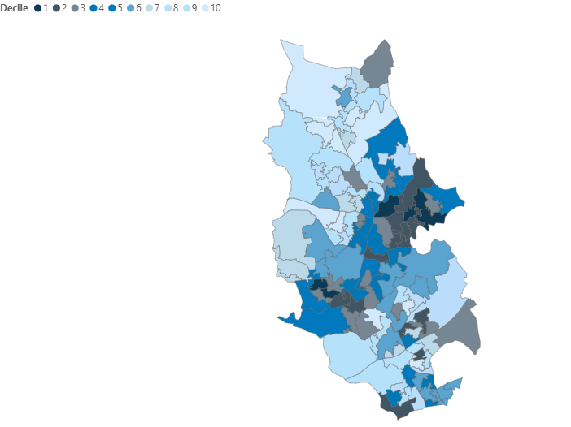

Education, Skills and Training Deprivation Domain Ranks for LSOAs in Bury
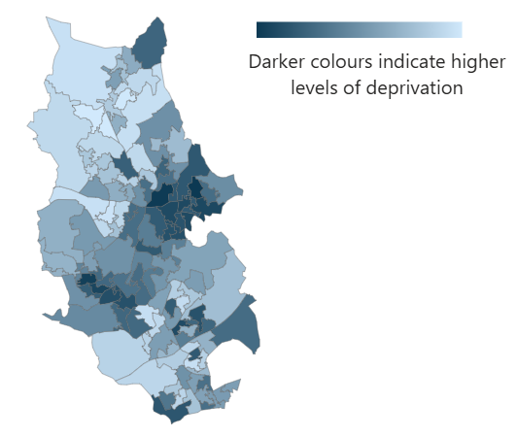

The below table shows the 10 most deprived LSOAs in Bury according to where they rank in comparison to all 33,755 LSOAs in England for the Education, Skills and Training Deprivation Domain for 2025.

LSOA name | LSOA description | Ward | Rank
Bury 007E | Chesham Fold | Moorside | 393
Bury 008C | Fernhill | Moorside | 718
Bury 016C | Radcliffe Boro FC/Coronation Road | Radcliffe North and Ainsworth | 1630
Bury 016B | Radcliffe Cricket Club/Water Street | Radcliffe West | 2731
Bury 007D | Teak Street/Hazel Avenue/Craven Street/Renshaw Drive/Bridgefield Drive | Bury East | 3101
Bury 008A | Villier Street/Percy Street/Pine Street | Bury East | 3337
Bury 008E | Pimhole Road/South Cross Street/Cecil Street/The Rock/Bus Depot/Market | Bury East | 3475
Bury 021B | Moss Lane/Ribble Drive | Besses | 3784
Bury 016D | Civic Centre/Town Hall/Victoria Street | Radcliffe West | 4290
Bury 011C | Springs - Townside Row/Killon Street/Alfred Street/Hampshire Close/Gigg Lane/Somerset Drive | Redvales | 4466

Health Deprivation and Disability Domain
The Health Deprivation and Disability Domain measures the risk of premature death and the impairment of quality of life through poor physical or mental health. The domain is comprised of four separate indicators measuring: illness and disability; premature mortality; acute morbidity; and mental health but not aspects of behaviour or environment that may be predictive of future health deprivation.
Bury has seen worsening relative deprivation for Health Deprivation and Disability - moving 10 places from rank 84 in 2019 to rank 74 in 2025.
The below maps show the Health Deprivation and Disability Domain for all LSOAs in Bury in 2025, where darker shading indicates a higher level of deprivation.

Health Deprivation and Disability Domain Deciles for LSOAs in Bury
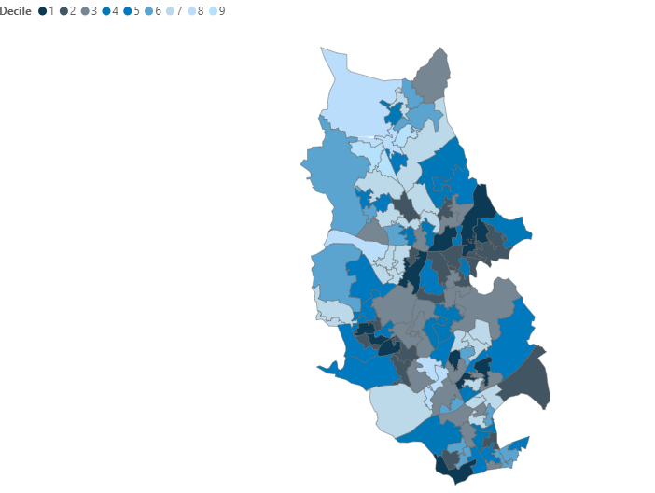

Health Deprivation and Disability Domain Ranks for LSOAs in Bury
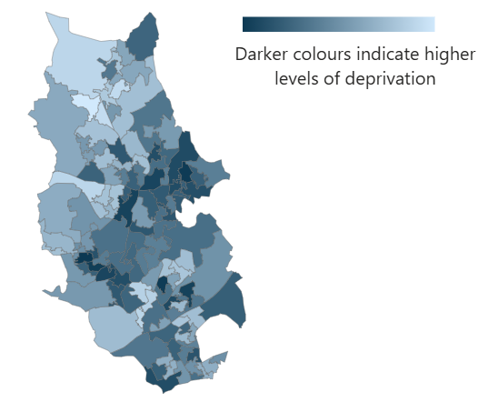

The below table shows the 10 most deprived LSOAs in Bury according to where they rank in comparison to all 33,755 LSOAs in England for the Health Deprivation and Disability Domain for 2025.

LSOA name | LSOA description | Ward | Rank
Bury 016C | Radcliffe Boro FC/Coronation Road | Radcliffe North and Ainsworth | 60
Bury 007E | Chesham Fold | Moorside | 346
Bury 020C | Elms North | Unsworth | 563
Bury 016B | Radcliffe Cricket Club/Water Street | Radcliffe West | 837
Bury 021E | Mersey Drive | Besses | 1495
Bury 009B | Daisyfield | Bury West | 1651
Bury 008C | Fernhill | Moorside | 2061
Bury 016D | Civic Centre/Town Hall/Victoria Street | Radcliffe West | 2138
Bury 021B | Moss Lane/Ribble Drive | Besses | 2888
Bury 007C | Danesmoor Drive/Hawk Close/Kestrel Drive | Moorside | 3025

Crime Domain
Crime is an important feature of deprivation that has major effects on individuals and communities. The Crime Domain measures the risk of personal and material victimisation at local level using eight indicators:
• Violence with injury, rate per 1,000 at risk population
• Violence without injury, rate per 1,000 at risk population
• Stalking and harassment, rate per 1,000 at risk population
• Burglary, rate per 1,000 at risk properties
• Theft, rate per 1,000 at risk population
• Criminal damage, rate per 1,000 at risk population
• Public order and possession of weapons, rate per 1,000 at risk population
• Anti-social behaviour, rate per 1,000 at risk population.
Bury has seen improved relative deprivation for Crime - moving 10 places from rank 50 in 2019 to rank 60 in 2025.
The below maps show the Crime Domain for all LSOAs in Bury in 2025, where darker shading indicates a higher level of deprivation.

Crime Domain Deciles for LSOAs in Bury

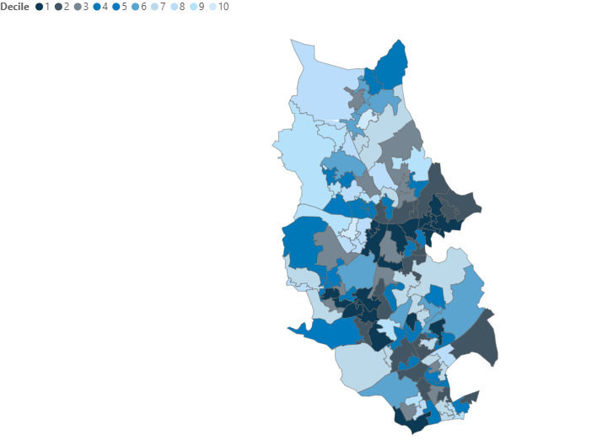

Crime Domain Ranks for LSOAs in Bury

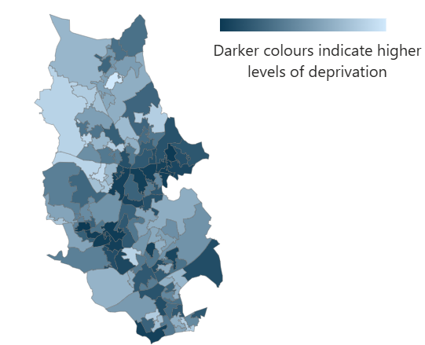

The below table shows the 10 most deprived LSOAs in Bury according to where they rank in comparison to all 33,755 LSOAs in England for the Crime Domain for 2025.

LSOA name | LSOA description | Ward | Rank
Bury 016C | Radcliffe Boro FC/Coronation Road | Radcliffe North and Ainsworth | 121
Bury 007E | Chesham Fold | Moorside | 250
Bury 015D | Metrolink Station/Coney/New School | Radcliffe East | 663
Bury 008B | Willow Street | Bury East | 873
Bury 016B | Radcliffe Cricket Club/Water Street | Radcliffe West | 948
Bury 016D | Civic Centre/Town Hall/Victoria Street | Radcliffe West | 989
Bury 011B | Bolton Street/Millet Street/Manchester Road/Richmond Street/Bury Interchange | Redvales | 1186
Bury 008E | Pimhole Road/South Cross Street/Cecil Street/The Rock/Bus Depot/Market | Bury East | 1209
Bury 016E | Coronation Park/Town Centre | Radcliffe East | 1251
Bury 009B | Daisyfield | Bury West | 1486

Barriers to Housing and Services Domain
The Barriers to Housing and Services Domain measures the physical and financial accessibility of housing and local services. The indicators fall into two sub-domains: ‘geographical barriers’, which relates to the geographical (in)accessibility of key local services and amenities; and ‘wider barriers’ which relates to broader issues of accessibility, such as access to affordable housing and other important services.
Bury has seen worsening relative deprivation for Barriers to Housing and Services - moving 30 places from rank 277 in 2019 to rank 247 in 2025.
The below maps show the Barriers to Housing and Services Domain for all LSOAs in Bury in 2025, where darker shading indicates a higher level of deprivation.
Barriers to Housing and Services Domain Deciles for LSOAs in Bury
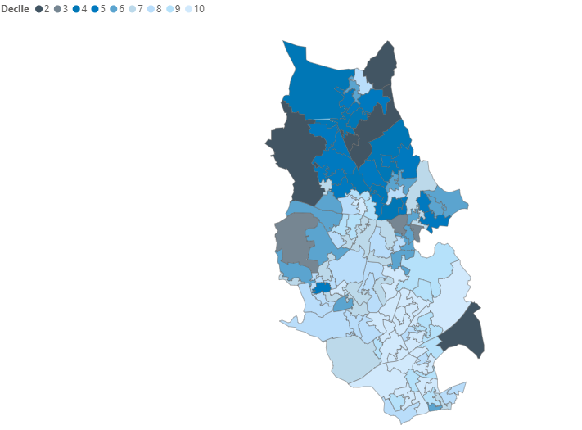

Barriers to Housing and Services Domain Ranks for LSOAs in Bury
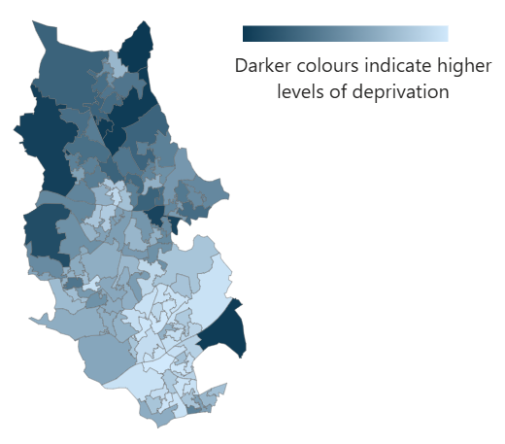

The below table shows the 10 most deprived LSOAs in Bury according to where they rank in comparison to all 33,755 LSOAs in England for the Barriers to Housing and Services Domain for 2025.
LSOA name | LSOA description | Ward | Rank
Bury 001B | Shuttleworth | Ramsbottom | 5346
Bury 002B | Newcombe Road Higher Summerseat | North Manor | 5746
Bury 003B | Rowlands Road/Summerseat | North Manor | 5832
Bury 022A | Simister | Holyrood | 5835
Bury 003C | Turton Road Tottington | Tottington | 6516
Bury 008E | Pimhole Road/South Cross Street/Cecil Street/The Rock/Bus Depot/Market | Bury East | 7144
Bury 012C | Ainsworth West | Radcliffe North and Ainsworth | 8540
Bury 008C | Fernhill | Moorside | 12013
Bury 001F | Holcombe Moor | Ramsbottom | 12017
Bury 005C | Brandlesholme Estate | Elton | 12041

Living Environment Deprivation Domain
The Living Environment Deprivation Domain measures the quality of both the ‘indoor’ and ‘outdoor’ local environment. The indicators fall into two sub-domains. The ‘indoors’ living environment measures the quality of housing; while the ‘outdoors’ living environment contains measures of air quality and road traffic accidents.
Bury has seen worsening relative deprivation for Living Environment Deprivation - moving 71 places from rank 124 in 2019 to rank 53 in 2025.
The below maps show the Living Environment Deprivation Domain for all LSOAs in Bury in 2025, where darker shading indicates a higher level of deprivation.

Living Environment Deprivation Domain Deciles for LSOAs in Bury
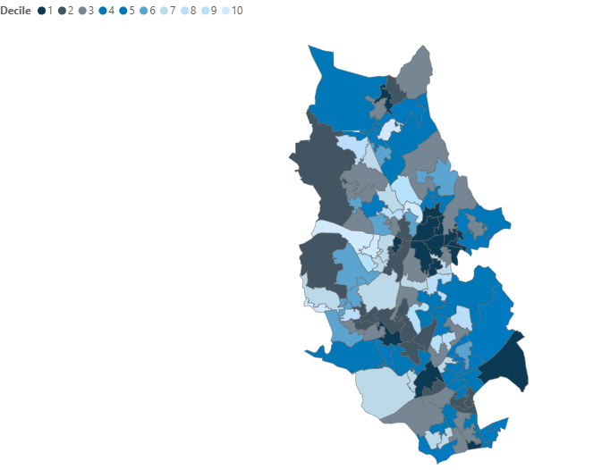
Living Environment Deprivation Domain Ranks for LSOAs in Bury
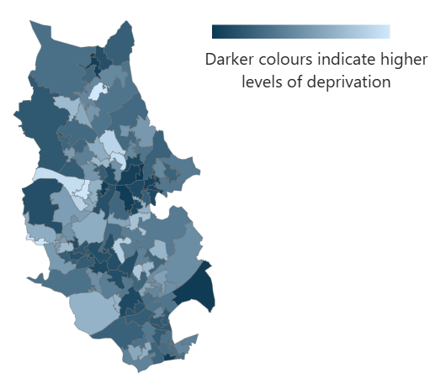

The below table shows the 10 most deprived LSOAs in Bury according to where they rank in comparison to all 33,755 LSOAs in England for the Living Environment Deprivation Domain for 2025.

LSOA name | LSOA description | Ward | Rank
Bury 008D | Cateaton Street | Moorside | 205
Bury 022A | Simister | Holyrood | 649
Bury 011B | Bolton Street/Millet Street/Manchester Road/Richmond Street/Bury Interchange | Redvales | 756
Bury 026E | Kings Road Area | Sedgley | 915
Bury 009A | Whitehead Park | Bury West | 1023
Bury 001C | Pinners Street/Top Wood/Carr | Ramsbottom | 1346
Bury 008C | Fernhill | Moorside | 1573
Bury 008A | Villier Street/Percy Street/Pine Street | Bury East | 1697
Bury 008B | Willow Street | Bury East | 2153
Bury 011D | Wellington Road/Grafton Street/Gigg Lane/Rhiwlas Drive | Redvales | 2835

Domains of deprivation – Bury’s ranks
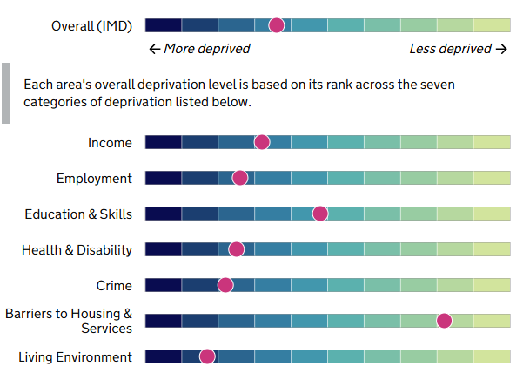
Bury has seen improved relative deprivation in 3 of the 7 domains:

- Income – moving 5 places from rank 83 in 2019 to 88 in 2025
- Employment – moving 14 places from rank 57 in 2019 to 71 in 2025
- Crime – moving 10 places from rank 50 in 2019 to 60 in 2025

Bury has seen worsening relative deprivation in 4 of the 7 domains:
- Education, Skills and Training – moving 25 places from rank 164 in 2019 to 139 in 2025
- Health Deprivation and Disability - moving 10 places from rank 84 in 2019 to 74 in 2025
- Barriers to Housing and Services - moving 30 places from rank 277 in 2019 to 247 in 2025
- Living Environment - moving 71 places from rank 124 in 2019 to 53 in 2025

Domain | 2019 | 2025 | Change +/-
Income Deprivation | 83 | 88 | +5
Employment Deprivation | 57 | 71 | +14
Education, Skills and Training Deprivation | 164 | 139 | -25
Health Deprivation and Disability | 84 | 74 | -10
Crime | 50 | 60 | +10
Barriers to Housing and Services | 277 | 247 | -30
Living Environment Deprivation | 124 | 53 | -71

Supplementary indices of the Income Deprivation Domain
This section explores the supplementary indices of Income Deprivation Affecting Children (IDACI) and Income Deprivation Affecting Older People (IDAOPI). These indices describe deprivation in terms of proportions of deprived people so allow for more direct comparison of deprivation between areas.
The below table shows Bury’s rank for both supplementary indices
Supplementary Indices | 2019 | 2025 | Change +/-
Income Deprivation Affecting Children Index (IDACI) | 119 | 97 | -22
Income Deprivation Affecting Older People Index (IDAOPI) | 109 | 116 | +7

Income Deprivation Affecting Children Index (IDACI)
The Income Deprivation Affecting Children Index (IDACI) measures the proportion of all children aged 0 to 15 living in income deprived families. Family is used here to indicate a ‘benefit unit’, that is the claimant, any partner and any dependent children for whom Child Benefit is received. This is one of two supplementary indices and is a sub-set of the Income Deprivation Domain.
Bury has seen worsening relative deprivation for IDACI - moving 22 places from rank 119 in 2019 to rank 97 in 2025.
Among the 10 Greater Manchester Local Authorities, Bury has seen the largest rise in rankings for Income Deprivation Affecting Children Index (IDACI).
The below maps show the Income Deprivation Affecting Children Index for all LSOAs in Bury in 2025, where darker shading indicates a higher level of deprivation.
Income Deprivation Affecting Children Index Deciles for LSOAs in Bury
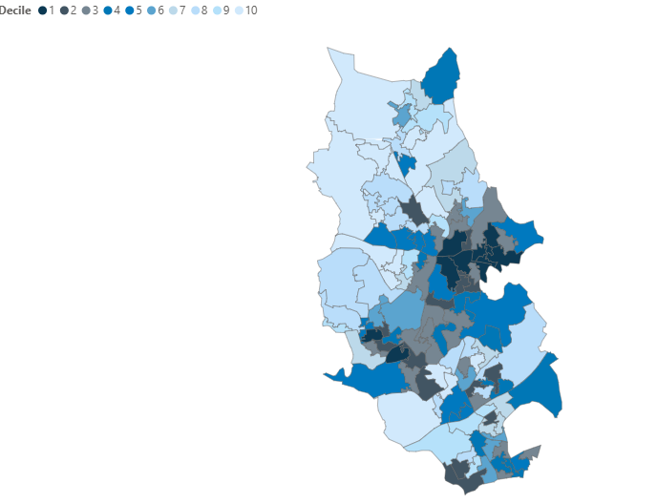
Income Deprivation Affecting Children Index Ranks for LSOAs in Bury
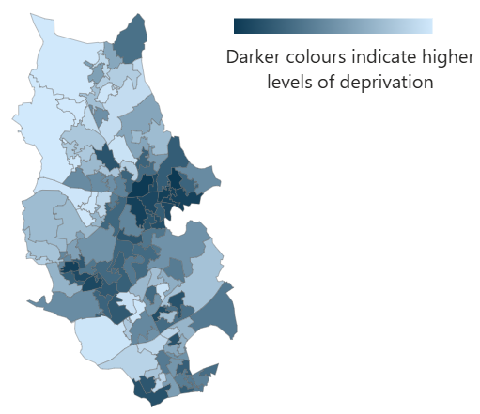

The below table shows the 10 most deprived LSOAs in Bury according to where they rank in comparison to all 33,755 LSOAs in England for IDACI for 2025.

LSOA name | LSOA description | Ward | Rank
Bury 007E | Chesham Fold | Moorside | 574
Bury 008C | Fernhill | Moorside | 709
Bury 008A | Villier Street/Percy Street/Pine Street | Bury East | 1600
Bury 016C | Radcliffe Boro FC/Coronation Road | Radcliffe North and Ainsworth | 1918
Bury 011B | Bolton Street/Millet Street/Manchester Road/Richmond Street/Bury Interchange | Redvales | 1936
Bury 007D | Teak Street/Hazel Avenue/Craven Street/Renshaw Drive/Bridgefield Drive | Bury East | 2101
Bury 008B | Willow Street | Bury East | 2111
Bury 008E | Pimhole Road/South Cross Street/Cecil Street/The Rock/Bus Depot/Market | Bury East | 3146
Bury 016D | Civic Centre/Town Hall/Victoria Street | Radcliffe West | 3247
Bury 008D | Cateaton Street | Moorside | 3452

Income Deprivation Affecting Older People Index (IDAOPI)
The Income Deprivation Affecting Older People Index (IDAOPI) measures the proportion of all those aged 60 or over who experience income deprivation. This is a second supplementary indices and is a sub-set of the Income Deprivation Domain.
Bury has seen improved relative deprivation for IDAOPI - moving 7 places from rank 109 in 2019 to rank 116 in 2025.
The below maps show the Income Deprivation Affecting Older People Index for all LSOAs in Bury in 2025, where darker shading indicates a higher level of deprivation.
Income Deprivation Affecting Older People Index Deciles for LSOAs in Bury
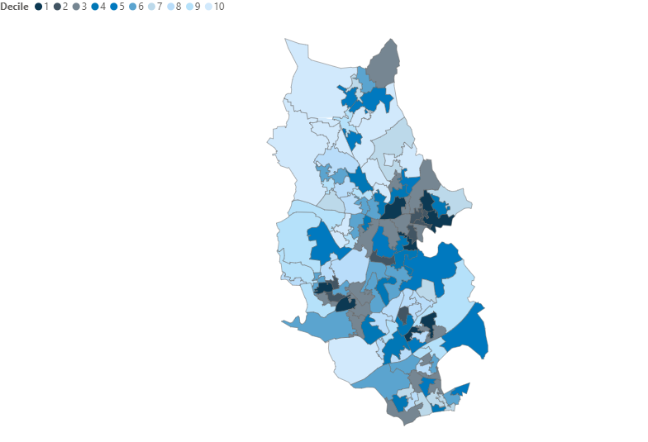

Income Deprivation Affecting Older People Index Ranks for LSOAs in Bury
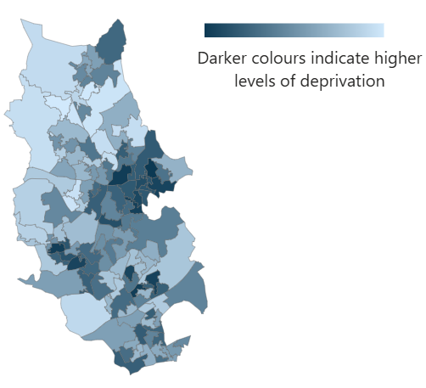

The below table shows the 10 most deprived LSOAs in Bury according to where they rank in comparison to all 33,755 LSOAs in England for IDAOPI for 2025.

LSOA name | LSOA description | Ward | Rank
Bury 007E | Chesham Fold | Moorside | 1086
Bury 008C | Fernhill | Moorside | 1843
Bury 021B | Moss Lane/Ribble Drive | Besses | 1970
Bury 016C | Radcliffe Boro FC/Coronation Road | Radcliffe North and Ainsworth | 2088
Bury 011C | Springs - Townside Row/Killon Street/Alfred Street/Hampshire Close/Gigg Lane/Somerset Drive | Redvales | 2400
Bury 021E | Mersey Drive | Besses | 2765
Bury 007D | Teak Street/Hazel Avenue/Craven Street/Renshaw Drive/Bridgefield Drive | Bury East | 3140
Bury 016D | Civic Centre/Town Hall/Victoria Street | Radcliffe West | 3205
Bury 020C | Elms North | Unsworth | 3472
Bury 008F | Killon Street/Ingham Street/Madon Street/James Street | Bury East | 3589

Further information
The Indices (including the IMD) can be found here, along with guidance and FAQs: https://www.gov.uk/government/statistics/english-indices-of-deprivation-2025

Previous versions of the Indices of Deprivation (2000, 2004, 2007, 2010, 2015 and 2019) are available from: https://www.gov.uk/government/collections/english-indices-of-deprivation

Contact
If you need any additional analysis using the new IoD including IMD, please contact the Performance & Delivery Team at PI.SDU@bury.gov.uk.

