|  |
| --- |
|  |



|  |  |
| --- | --- |
| Wellness Strategy  Bury Council  September 2022 | |
|  |  |

|  |  |
| --- | --- |
| **www.slc.uk.com** |  |

Document control

#### Amendment History

|  |  |  |  |  |
| --- | --- | --- | --- | --- |
| Version | Date | File Reference | Author | Remarks/changes |
| 1.0 | 28-09-22 | Bury Wellness Strategy | DWA | Final |

#### Sign Off List

|  |  |  |  |
| --- | --- | --- | --- |
| Name | Position | Date | Remarks/changes |
| Duncan Wood-Allum | Managing Director | 28-09-22 | Approved |

#### Distribution List

|  |  |  |
| --- | --- | --- |
| Name | Position | Date |
| Nicky Parker | Director of Transformation | 28-09-22 |
| Jackie Veal | Head of Wellness Services | 28-09-22 |
| Jon Hobday | Consultant in Public Health | 28-09-22 |

Contents

1. Background and Terms of Reference 4

2. Vision 11

3. Community Wellness Model and Concept 17

4. Case Studies 24

5. Wellness Business Model 34

6. Governance and Management Model 47

7. Wellness Facilities Investment – time to pivot? 50

8. Digital Transformation Programme 53

9. Glossary 55

# Background and Terms of Reference

## Background

### **Bury Council has identified that a whole new approach is required to transform (or pivot) its traditional leisure services through a completely new strategy and approach to the provision of Wellness services in Bury and a five-year development plan.**

### **It is a strategy and a movement that will put individual wellness and improved health outcomes at the centre, focuses on every township, with accelerated pace in Radcliffe and East Bury.**

### The Chief Executive is leading a working group which has taken the GMCA initiatives around the new Live Well Manifesto, GM Moving and the ‘A Moment to Pivot’ Programme led by the GM CEO’s as a starting point integrating township based enabling support and outreach, contributing to the delivery of Bury’s own Physical Activity Strategy (Bury Moving), learnings from the Sport England Local Delivery Pilot and wider Public Service Reform within Bury.

### It will focus primarily on the contribution of Leisure, Sport, Physical Activity and Wellness supported by aligning the strategy to Bury’s existing Wellness offer to deliver ambitious local outcomes, followed up in early 2023 by an investment strategy for Bury’s built facilities such as Leisure Centres in the first instance. It builds on learning from the three-year Sport England Pilot ‘I Will If You Will’ which ended in 2020. It requires a Team Bury approach with active ownership by the Council and its Team Bury partners as well as the voluntary sector and Sports Clubs, building on successful models such as the Goshen Campus and Rossendale Community Leisure Trust.

### The Council acknowledges the Wellness Service and its wider partners will need to reach out to communities within its six Townships where people live and enable lifestyle changes. These will support improved physical and mental health outcomes, reduce health inequalities and reduce demand and spend in other sectors, particularly the NHS and Adult Social Care.

### This business case heralds the opportunity for the Council to pivot and initiate a community led ‘movement for movement’ within Bury with an emerging vision of:

### ‘Using physical activity and culture to support and enable all aspects of wellness and reduce health inequalities in Bury’.

## Terms of reference: Refining thinking around a new Wellness Services Strategy

### The Council in partnership with local stakeholders has refined its thinking around a **Wellness Services Strategy** which has also been co-produced with local communities and will be implemented in phases through its neighbourhood People and Community Plans across its six Townships.

### Supporting this thinking has been the development of a glossary of terms which can be seen in Section 9.

### An integrated Community Wellness model has emerged.

### Supporting this, Bury Council has set out a clear end state for two key deliverables by 30 September 2022:

* **A) A business case for investment in a Wellness Services Strategy**
* **B) Strategic facilities fund application to Sport England for Radcliffe (LUF).**

### These are described in greater detail as follows:

## Business case for investment in a Wellness Services Strategy to support a Community Wellness Model

### Bury Council require scoping support for its Wellness Strategy Transformation programme, specifically to support the development of business case to demonstrate that investment in its six Townships for residents will reduce inequalities, improve physical and mental health outcomes and reduce spend across wider parts of the system.

### The business case will seek to:

### Scale up the Radcliffe People and Community Plan proportionately across the six townships

### **Position accessibility to local services at its heart**: proportionate to need, easy to find / navigate and affordable and;

* **Take a Public Sector Reform approach** and puts in place a multi-agency and voluntary sector-based delivery team with Public Health and community engagement at its heart
* Set out the role of Council Wellness Hubs (Virtual and Physical buildings) , parks, green spaces as well as VSCE and sports clubs as part of an integrated Community Wellness model.

### **Seek to demonstrate the extent to which it is possible to break even** in the longer-term taking account of social value, cashable and non-cashable savings within Health and Care and the wider system.

* Set out a cost benefit analysis / social value analysis to show the extent to which investment in Wellness activities and new wellness facilities can reduce downstream demand for Health and Care and other services
* Propose options for an appropriate governance model, particularly looking at the opportunities of a Community Trust

### **Set out the need for investment in new facilities** in Bury Town Centre alongside Radcliffe Hub (LUF) and makes a proposal about provision for Ramsbottom

* Addresses obligations around school swimming and Covid related water safety and confidence gap for years 5,6 &7
* Significantly reduce the carbon footprint of the wellness facilities compared to current assets
* Reduce revenue costs and optimise social value
* Takes account of wider regeneration opportunities in Bury
* Demonstrate how the local community will access the new rooftop wellness zone as part of the Radcliffe new Civic Hub Centre

### **Further develop the emerging Wellness Strategy** focused on improving health outcomes in all parts of the Borough, particularly accelerated in Radcliffe and East Bury and;

* Implement the GM initiatives around Live Well Manifesto, GM Moving and ‘A Moment to Pivot’ as part of a wider GM Plan to improve wellness
* Take the best practice e.g. Goshen model to scale up across Bury supporting a whole system approach to wellness in townships
* Integrate the roll out and the principles developed by the Local Delivery Pilot and upscale of the Local Pilot Delivery Plan in Radcliffe (GM Moving, Sport England funded £300k)

### Optimise the potential of digital transformation and integrated data management to:

* Use local insight / intelligence and data to support place-based co-delivery and service redesign – e.g. Bury Moving audit and Bury Directory
* Inform local priorities and evidencing improved outcomes and improve access to universal and targeted services
* Capitalise on GM wide and Bury specific marketing and communications campaigns (e.g. GM #KeepMoving).

### **Align the Wellness Strategy to the Climate Strategy** and action plan to enable active travel to replace car journeys.

## Strategic Facilities Fund bid application to Sport England

### The Council would like to identify the support it needs in developing a funding bid for Radcliffe Hub to secure Sport England funding (£1.5+ million) building on the successful levelling up funding bid it has already secured.

### SLC have been appointed to lead on the development of the business case and stage 1 EOI funding bid in close collaboration with the Project team and other Council colleagues.

## High Level Approach

#### Stage 1 Vision

### Stage 1 of the programme commenced late July 2022. The project inception meeting was combined with a virtual visioning workshop to seek to build on the work to date and develop a consensus on the overall vision for the wellness strategy. This was developed into a high quality visual with supporting layered visuals to communicate how Wellness will permeate through the six townships and local systems in Bury and specifically at a ward level in East Bury and Radcliffe.

#### Stage 2 Community Wellness Model Development

### Stage 2 is the key element of the overall service redesign where SLC worked with Bury colleagues and stakeholders to develop the organisational structures, functions and geographical focus of the evolving Wellness service. The Universal and Targeted offer was be explored in greater detail building on early concepts developed with Bury in the scoping stage. Through a workshop, consultation sessions and follow up engagement and refinement, a high-level organisational design featuring the Wellness Services facilities, neighbourhood functions, engagement teams and a management function was developed, building on existing resources in place.

### Explore community led approaches and the use of Cormac Russell’s three powerful questions:

* What are or could communities be doing for themselves?
* What are or could communities be doing for themselves with support?
* What things do communities need public services to do for them?

#### Stage 3 Case Studies

### Stage 3 focused on the development of local and exemplar case studies to communicate what the Wellness Strategy can achieve, scale and replicate locally. Up to 4 Case studies were developed linked to a compelling visual design linked to the overall vision of the Wellness Strategy. The team will explore the Goshen model and other examples of best and innovative practice such as the Rossendale Leisure Trust’s approach to wellness.

#### Stage 4 Business Model

### Stage 4 focused on the development of the financial model underpinning the Wellness Strategy and had a number of elements relating to: the management function to lead the Wellness Strategy, wellness / leisure facilities operations and the Community partnership and Community Champion teams supporting and enabling physical activity within communities in the six townships. A high-level business plan was developed to ensure the Council can develop options that can be scaled linked to availability of revenue funding.

### Complementing the business model will be the application of the Greater Manchester CBA model (new beta version) to this Wellness Strategy Programme to demonstrate at high level the wider economic and social value both cashable and non-cashable of the interventions the service will deliver. CBA has become a central element in the development of business cases for new and innovative ways of working in Greater Manchester. The CBA model is used to understand the value for money provided by an intervention, particularly in terms of the use of taxpayers’ money and the extent to which new delivery models might generate savings and improved outcomes compared to ‘business as usual’ – the ‘financial case’ within the Green Book five case model. The model also enables the wider ‘economic case’ or public value to be articulated, quantifying economic benefits that accrue to individuals and businesses, and social benefits in terms of improved individual health and well-being. CBA outputs include quantification of the return on investment (ROI), and provided there is a positive ROI, the pay-back period – how long it will take before the benefits start to outweigh the costs.

### The CBA approach can be used to consider the value for money offered by different interventions that may otherwise not be easily compared. It provides valuable intelligence on the equitability of funding – by demonstrating the money flows between organisations that invest in an intervention and those that derive the benefits, it can inform development of new investment models characterised by a partnership approach to resourcing activity and sharing the benefits from that activity.

### The CBA model is used extensively across the country by public, private and voluntary and community sector partners. The methodology has been applied to a wide range of intervention types, including: supported families programmes; employment and skills initiatives; health and social care propositions; new approaches to delivering early years’ services; and redesigns of criminal justice system interventions and blue light services. This will be an effective and accepted methodology to capture the downstream savings that this Strategy can achieve over the longer term supported by clear assumptions.

### A workshop will play back the early business model to enable refinements to be made and get a clear steer on the approach to exploring options linked to available resources and time constraints.

### Following this, further refinements will be made and supporting graphics developed for the presentation of the Business Case at the end of October.

### SLC has also commissioned 4global to undertake a Social Value analysis of Radcliffe Civic Hub and the Wellness Model across the 6 townships.

### “Social Return on Investment in Sport: A participation wide model for England” was published in 2016 by Sheffield Hallam University (SHU) and was as the basis for social value calculations previously. In 2019 Sport England commissioned an update to the national model for England and the updated guidance has been incorporated into the social value calculations in this report. This new version is aligned with the UK Government strategy for sport, Sporting Future – A New Strategy for an Active Nation.

### The key categories explored within the model feature:

Improved physical and mental health

### Eight health outcomes (reduced risk of various health conditions) were valued by estimating the number of reduced cases resulting from physical activity participation multiplied by the average annual cost per person diagnosed with the condition.

### Reduced GP visits and psychotherapy usage was calculated by estimating the reduced likelihood of visiting the GP 6+ times per year/ using psychotherapy services, multiplied by the average annual cost savings per person.

### Injuries were valued by multiplying the number of A&E attendances recorded as sport injuries by the average annual cost of an injury. Different than the other indicator, this has a negative impact on the total social value.

### The SVC3 modifies health values for age, gender and NS-SEC category, using weights which are derived using the prevalence of disease reported in the Health Survey for England.

Improved subjective wellbeing

### Subjective wellbeing was calculated by multiplying the value of increased wellbeing derived from a participant’s engagement in sport (using the wellbeing valuation approach) by the number of unique people taking part.

### The wellbeing valuation approach uses large scale survey data to estimate the impact of sport on people’s self-reported wellbeing and uses these estimates to calculate the amount of money that would produce the equivalent impact on wellbeing. The wellbeing value represents the hypothetical income required to compensate for not benefitting from wellbeing enhancement through participation in sport and physical activity.

Improved individual development

### Educational attainment was valued by estimating the number of additional sports participants with formal qualifications (level 2 and level 3) by the average lifetime productivity returns.

### The human capital outcome represents the value of an individual’s enhanced skills, gained through participating in sport at university. It was valued by estimating the number of final year students in Higher Education Institutions doing sport, multiplied by the average additional starting salary for sports participants.

Improved social and community development

### The crime outcome was valued by estimating the number of criminal incidents prevented amongst males in the 10-24 cohort taking part in sport, multiplied by the average cost per incident of crime.

### Social capital was valued in a similar way subjective wellbeing, using the wellbeing valuation approach: the higher value of social capital derived from a participant’s engagement in sport was multiplied by the number of unique people taking part in sport. The social capital value represents the hypothetical income required to compensate for not benefitting from social capital enhancement through participation in sport and physical activity.

#### Stage 5 Governance & Management Model

### Stage 5 focused on exploring an optimal governance and management model to support the Wellness Strategy. Building on SLC’s previous experience consultation took place with exemplar organisations (as mentioned previously) to inform development of the potential options that could work effectively for Bury.

### Once the shortlisted options had been explored and the Council provided a steer, a high-level options appraisal workshop selected the optimal option based on pre-developed evaluation criteria and supporting information to explore advantages and disadvantages of respective models. Options included: In house (baseline) Community Trust and blended models linked to externalised back office support.

### The preferred option was then be built into the high-level business plan linked to assumptions on VAT and NNDR treatment and relative financial performance of the baselined leisure / wellness facilities in scope.

#### Stage 6 Wellness Facilities Investment

### Stage 6 will seek to develop a clear position on the assumptions underlying the current leisure portfolio and its transformation. Building on the Radcliffe Civic Hub and setting out a strong case for investment in the Rooftop Wellness Zone, there is still work to do on options to address the Ramsbottom and Castle facilities. The consultant will draw on regeneration experts to support the options for Mill Gate relating to any future provision of Castle Leisure Centre at a high level to enable clear assumptions to be made within the business plan and business case overall. Linked to this will be the development of a clear direction of travel and recommended way forward for both Ramsbottom and Castle which could link to supporting redevelopment of provision. This will be linked to the scope of a leisure-built facilities strategy and or focused feasibility work.

#### Stages 7: Digital Transformation Programme

### Stage 7 will explore at a high level an approach to Digital Transformation Strategy, key features and benefits and set this out linked to timescales and costs, building on the early investment into the leisure facilities and digital transformation work undertaken within Bury and across GM. The output will be a costed programme for inclusion within the business case.

#### Stage 8: Supporting the Climate Strategy

### Stage 8 will ensure that the Wellness Strategy optimises the opportunity to bring together all current policy initiatives and commitments linked to active travel, walking and cycling and decarbonisation linked to modernisation of the leisure facilities. As part of this focused work, the scope for a piece of work post business case will seek to establish the impact that investment in the leisure portfolio (including Radcliffe) can have on the Council’s Net Zero targets in the future.

#### Stage 9: Strategic Facilities Fund Bid

### A key objective of this programme in Stage 9 is to secure £2 million of funding from Sport England. SLC worked with the Council to develop a funding bid (Expression of Interest) by the end of September, building on the work undertaken to date.

#### Stage 10: Business Case Development

### Finally, in Stage 10, SLC developed the business case in a form agreed with the Council to be delivered for the end of October 2022. They provided a supporting highly visual presentation, using graphics developed to support the business case as set out in the resource plan. This was completed ready for the end of October 2022.

#### Acknowledgements

### SLC would like to thank all Bury Council colleagues and wider stakeholders involved in this Business Case for their input and support.

# Vision

A Vision for Wellness

## Introduction

### SLC facilitated two workshops on 9 and 10 August to accommodate colleagues’ availability.

### Meeting notes from both sessions can be seen in Appendix 2.

* Attendees included representatives from:
* Early Help and School Readiness), Bury Council
* Law + Democratic Services, Bury Council
* Finance, Bury Council
* NHS Bury CCG
* Six Town Housing
* Operations, Bury Council
* BIG Team Levelling Up Project Delivery (Radcliffe), Bury Council
* Bury VCFA
* Wellness Strategy Project Team
* SLC.

## Core areas explored

### Two key questions were explored in both sessions:

* + - 1. **What does a successfully implemented wellbeing approach look like in Bury in 2030? and;**
      2. **How do we articulate the Vision to bring others on board?**

## What does a successfully implemented wellbeing approach look like in Bury in 2030?

### Prompts

* Why should we take a Wellbeing approach?
* How does this approach align with our LETS Vision and Values?
* From a community perspective what would it look and feel like?
* Who and what forms part of a Wellbeing Community?

## Headline Themes

### There were two overarching themes which emerged frequently:

* **Communty-led:** working with as many willing organisations, stakeholders, volunteers and residents as possible to co-create and grow opportunities using local skills, expertise and assets (Nothing about us without us)
* **Everyone included:** whether that be digitally, demographically, culturally, or in terms of ability; with additional resources for those least likely to participate and who experience the greatest health inequalities (Proportionate Universalism)

### Other key themes that emerged are as follows:

Strategic

* LETS emphasises community wealth and wellbeing and economic growth and development, not just cost savings.
* Need to consider all ages and whole family approaches.
* Link to wider GM work – e.g. Live Well Manifesto and GM ‘A Moment to Pivot’ Programme.
* Whilst more than leisure, benefit-cost ratio calculations for Radcliffe Levelling Up bid showed £33m in health and wellbeing benefits from PA for Hub (out of total £92m social benefit).
* Culture also big part of the BCR calculation and is linked to sense of pride and belonging in local area.
* Do a smaller number of things well rather than stretch too thinly.
* A culture of learning and considering both long and short-term outcomes.

#### Health

* Mental and physical health are both equally important.
* Social prescribing is a huge opportunity for PA as a referral pathway and as a link into supporting wider work of PCNs.

#### Local/community

* Everything needs to be locally led.
* Needs to be more than consultation – co-creation at every stage.
* Use the assets and spaces that are already there – don’t always need shiny new or big facilities.
* Wide definition of physical activity but sport still has an important role to play; sports environments can be tailored to be inclusive and fun rather than elite and competitive.
* Big role of green and blue spaces/outdoors (especially linked to mental health)
* Investment is needed in VCSEs if they are to take on supporting more people (e.g., through social prescribing).

#### Volunteers

* Big opportunity to embrace the approx. 1200 groups of the volunteer sector (covid lessons) if they are supported in the right way and feel part of it. Council can’t do everything.
* Nature of volunteering has shifted, micro-volunteering and younger people volunteering.
* Activity champions – the concept was appealing but the name could put some people off (champions sounds quite lofty). Paid staff need to offer support and coordination. ‘Champions’ could be hosted within the volunteer sector to ensure they are supported (e.g., Bury Defence Academy).

#### Other

* Schools – are they doing enough and are the council engaging with them enough? How can we open up school space more? N.B. School capacity is limited so need to provide resource to open in holidays.
* Digital approaches – valuable to some but off putting to others; need to have viable alternatives for everyone.
* Swimming safety provision need to be adequate (including to catch-up backlog).
* Support for families who struggle with water confidence.
* Six Town Housing have 7.5k properties and a big cross over with inactive people. New Tenancy Sustainment Strategy – to keep tenants longer-term. Anything that provides a better quality of life makes people more committed to staying. Opportunity for 6TH to work with VCFA on this.

## How do we articulate the Vision to bring others on board?

#### Vision Format

* Needs to be something visually impactful; an accompanying narrative might be useful to help talk through it with stakeholders
* General support for presentation as an ‘ecosystem’ however current mock-up is too service-based and ‘public sector-ey’
* Needs to give more of a sense of what this will look and feel like to the community
* Needs to encompass all aspects of Wellness - physical, mental, social, emotional
* Needs to be more person-centred, including:
* Participants
* System leaders
* Volunteers and Neighbourhood leaders (Community Champions?)
* Partner organisations
* Communities being supported.
* Needs to reflect what will be achieved (outcomes) not just the offer (particularly for funders)
* Business Case may need a more generic model which represents all Bury, but emphasise that each township will have the opportunity to create its own bespoke if investment is approved.

### Key features to include:

* The people who make up the system (participants, partners, and champions)
* Local community assets – including green spaces, paths, institutions, homes, community spaces
* Links between people, opportunities and places
* Headline wellness outcomes & savings
* Reflection of tackling inequalities (e.g. universal v targeted^ offer) and who key audiences are*
* Idea of ‘cradle to grave’ and whole family approaches – e.g. **start well, live well and stay well**.

#### Visual Options

* Images of new Radcliffe Hub, or other local landmarks, so it is recognisable to local people
* Montage of photographs doing activities, e.g., walking, cycling, playing etc.
* A person (local resident) in the middle.
* (If available**) compelling attention grabbing on:
* long-term savings and;
* wellbeing benefits to community.

Wish List

### As part of this approach, delegates were asked to develop an emerging **wish list** to support the articulation of the Vision and to support the development of the Wellness Model.

* Process
* System mapping – provision, partners, audiences, etc
* Proportionate Universalism
* Targeted offer for those who need most support
* Skills development for children in low-income families (e.g. learn to swim, cycle)
* Walking and Cycling
* Enhanced walking and cycling infrastructure
* Promotion of Active Travel (functional) and walking and cycling for recreation
* Leverage funding for transport into Bury (e.g., Active Travel LA Allocation to GMCA; Community Renewal Fund Towns Fund)
* Support for the full range of physical activity, e.g.,
* Walking
* Gardening
* Activity at home
* Dance
* Sport
* Fitness
* Workforce
* Volunteer programme ‘community champions’ with paid support team
* Youth volunteering – leverage YP enthusiasm about new facilities
* Local Communities/Community sector
* Investment in capacity of community organisations
* Link with other community initiatives (e.g. healthy eating support)
* Link with family-based approaches (e.g. HAF)
* Link with Neighbourhood Planning
* Physical assets
* All facilities prioritise community use
* Opening up community assets (e.g. schools, community centres, LA properties) for community use
* If we want to use schools and other assets need to ensure we provide support (e.g. to open buildings out of school time)
* Use of non-typical venues, especially where high density of those experiencing inequalities (e.g. Bury Market)
* Co-location of wellness services
* Adequate swimming provision to support water safety
* Health sector
* Viable physical activity referral options for social prescribers, physios, occupational therapists and other HCPs (linked to investment in community sector capacity)
* Link with mental health support and treatment pathways
* Link with other NHS support programmes (e.g. addiction support, stop smoking, weight management)
* Community engagement & co-creation steers activities and environments created
* Township level (or even more local where appropriate)
* Link to existing opportunities (e.g. new Pupil Parliament starting Autumn, Radcliffe Growing Together)
* Target audiences where high inequalities exist (e.g. Housing Association residents)
* Bring “what’s in it for me” brigade on board, who don’t see point of regeneration (where possible)
* Connect to youth audience (particularly for co-creation); RL has strong connections
* Funding
* “Down your Street” small grants (e.g. £100) for hyper local community activity (e.g. street clean, community garden)
* Community Renewal Fund Towns Fund – Chris Logue’s team leading, links to Radcliffe Transport Strategy. Consultant (Simon Dickinson, Mace) helping scope a business case for Streets for All.
* Adequate housing for good health
* How can PA be linked to this area of work?

### Delegates were asked who the potential delivery organisations / stakeholders could be.

#### Potential delivery organisations/stakeholders

* Health and social care sector: Social prescribers, NHS health support services, mental health nurses, occupational therapists, physios, care homes, home care support
* Carer support organisations
* Food banks
* Housing Associations
* Schools
* Sports Clubs
* Other Community Clubs (e.g., gardening clubs, walking groups)
* VCSE organisations who support (or could support) wellness
* Faith Groups

Family support groups/hubs

* Disability Support Organisations
* Health Charities (e.g. Macmillan, MIND)
* Transport sector

Park, playing field, and green space owners/managers

* Gigg Lane (investment for community use)
* Bury Market.

## Vision Outputs

### SLC has developed the following high-level outputs based on the principles underpinning the Vision and the Vision visual and statement itself. See Figures 1 and 2.

Figure 1 – Vision principles

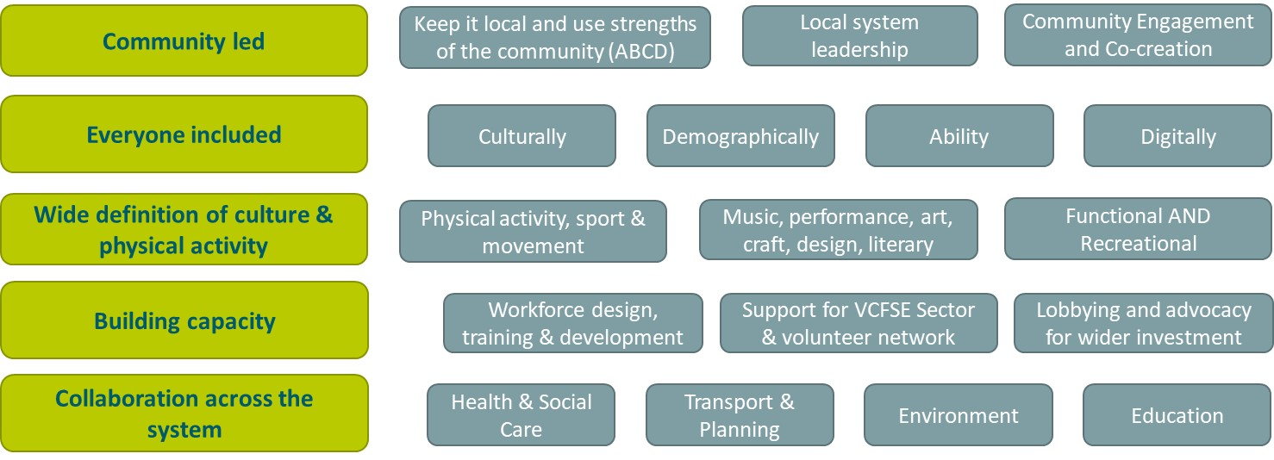

Figure 2 – Vision

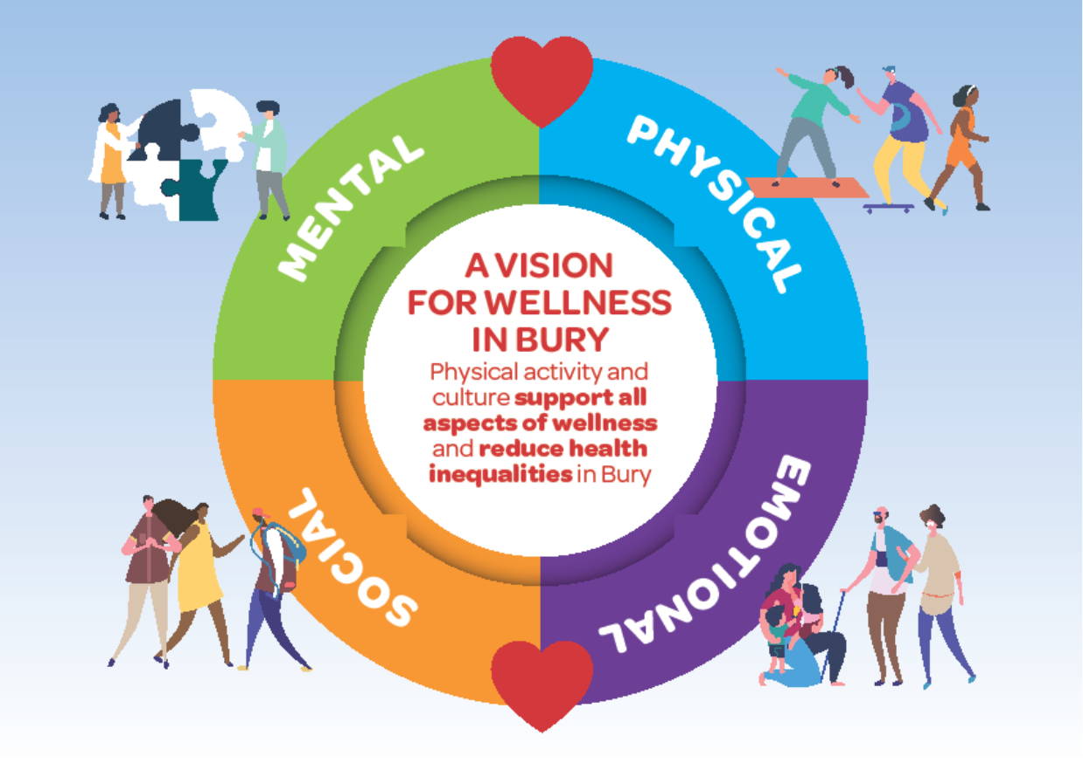

# Community Wellness Model and Concept

Developing the Wellness Model

## Approach

### SLC facilitated two workshops – firstly one with representatives from;

* Senior Leadership, Bury Council
* Transformation, Bury Council
* Wellness, Bury Council
* Public Health, Bury Council
* VCFA
* Adult Social Care, Bury Council
* Integrated Teams East Bury
* Integrated Care System
* Strategic Partnerships, Bury Council
* Hub Manager, Bury East

### This session played back progress to date on the development of the Vision and glossary of terms and sought feedback from delegates.

### Key points highlighted are shown below.

* Not all communities in a township the same, or protected communities the same, from an inclusion perspective, different approaches for delivery will be required at a micro level.
* Sport has a role to play, in terms of activity benefit, cultural connection, volunteers, common purpose and community spirit. e.g. Prestwich football club
* Need to be cautious about formalising role of volunteers – need to link to existing organisations, with no requirement for new infrastructure, support, expenses, training, management required.
* Internally 5 neighbourhoods and externally 6 townships should be used in any communications.

### Delegates discussed and fed back on the eco system, core universal and illustrative targeted offer visuals in figures, 4 and 5.

Figure 3. Eco System

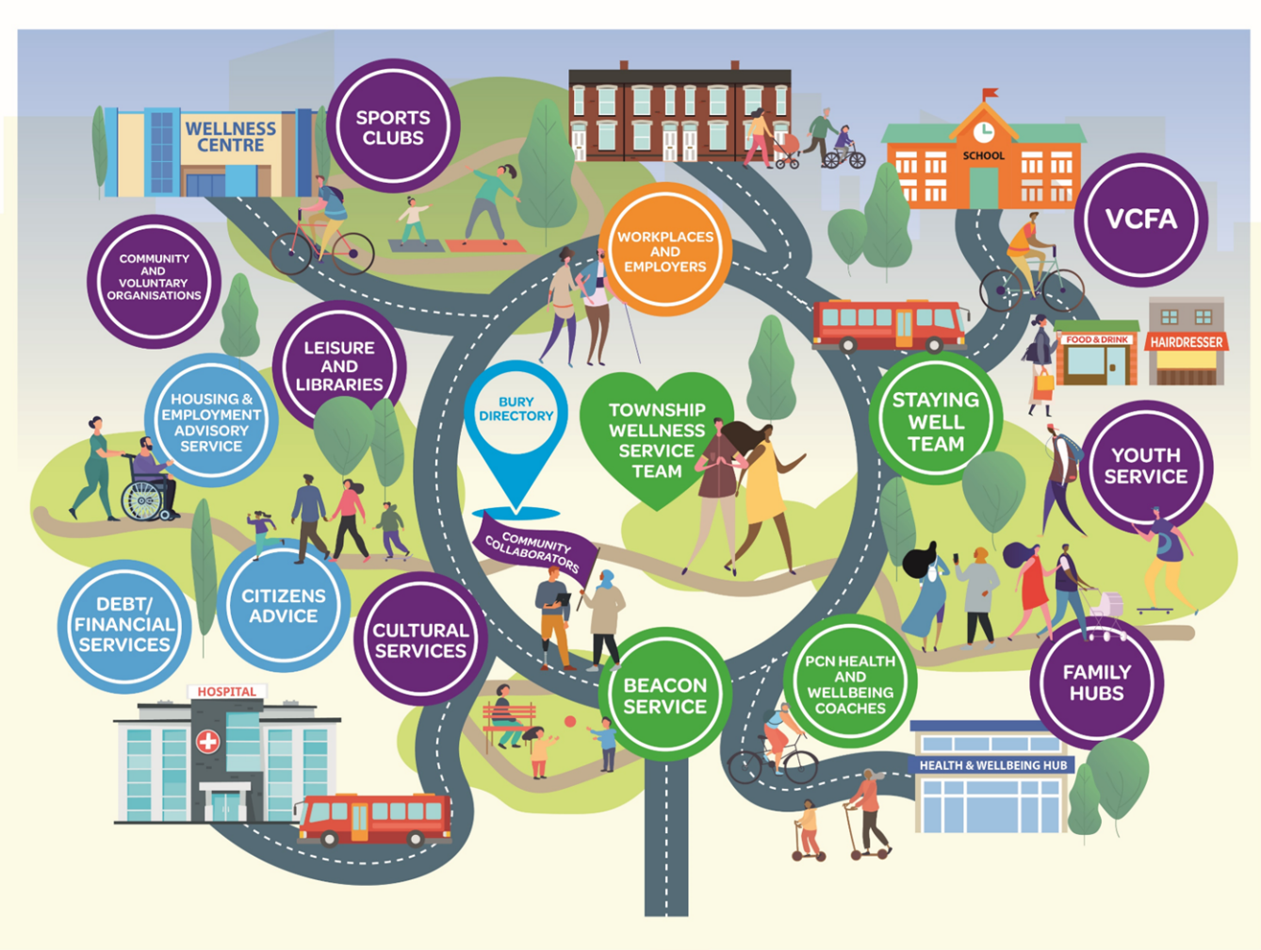

Figure 4. Core Universal Offer

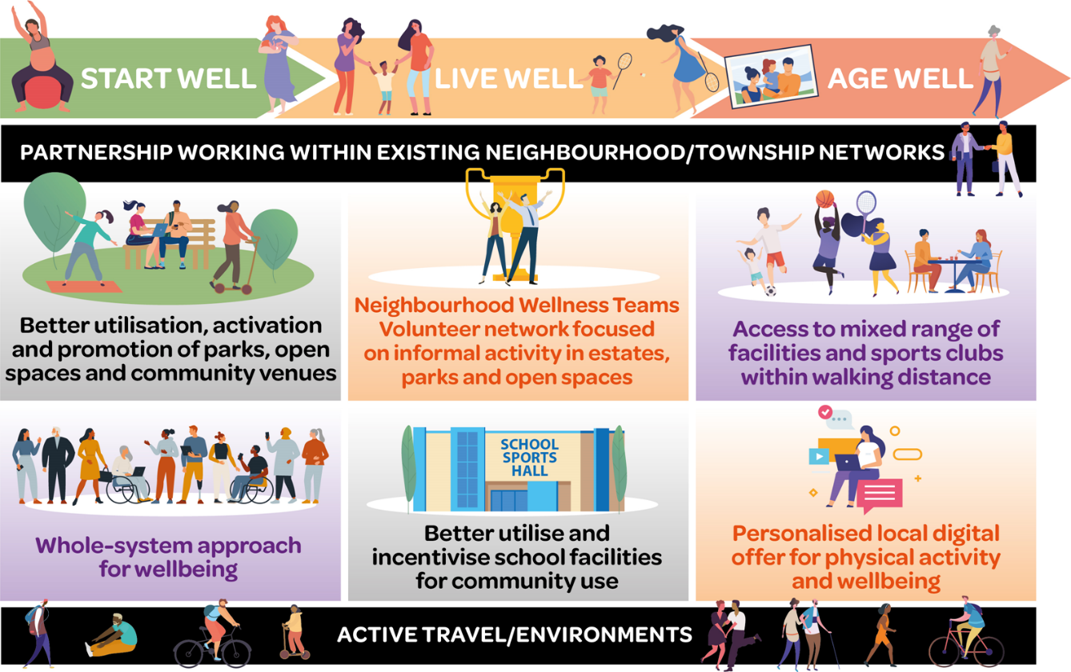

Figure 5 Core Targeted Offer

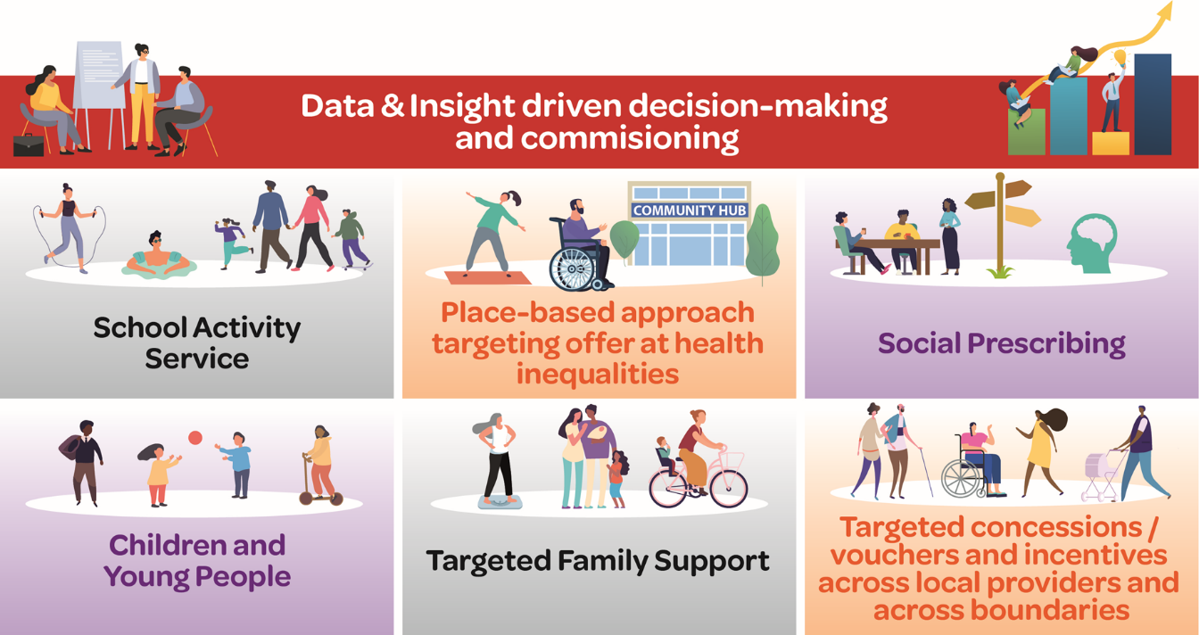

### Key comments / observations were as follows:

* For people new to the Vision and supporting models there was a need to walk them through the collective layers to support their wider understanding of the Wellness Model and its layers.
* Recognise that some communities will gravitate to new Radcliffe Hub
* Move closed door programmes, e.g., strength and balance sessions into the open
* Culture side – need to emphasise the linkages
* Build on what we have, health improvement fund, 114 groups did this, start small, discrete small activities at their level, in their community, how do we build? How do we link back into leisure facilities, entice them into the offer?
* Voluntary sector, connectively through social prescribing, some referring is going on.
* Making sure that there is oversight, see what is happening to join the dots at Township level
* Supporting voluntary sector groups doing a good job, helping them to grow.
* Model being described, elements exist, existed at small scale (pilots or one off) How do we achieve scale? How do we achieve sustainability? How do we create something that is visible? How do we support existing endeavours using Council resource?
* It’s about creating a movement that is embedded into the system
* Good example: Fit and Fed, small direct support resources and with volunteers & coaches that they can go to, cultures are there but need some initial support
* Need to target interventions around offers that the private sector cannot provide, e.g. public swimming provision
* Statutory duty of swimming provision, needs to be delivered by a facility. Different ways of fulfilling a statutory duty, but need to demonstrate a realistic and appropriate approach to delivery. Need for travel time analysis
* Need more visibility of activity in localities e.g. public space yoga.
* Focus on water safety is key, rather than focus on KS2 obligations.

### This was followed by a Senior Leadership Team Workshop with the following attendees:

* Lesley Jones, Director of Public Health Bury Council (Chair)
* Donna Ball, Executive Director of Operations, Bury Council
* Nicky Parker, Director of Transformation, Bury Council
* Jon Hobday, Public Health Consultant, Bury Council
* Liam Johnson, Workforce Transformation Lead, Bury Council
* Kate Waterhouse CIO, Bury Council
* Neil Long, Assistant Director – Operations, Bury Council
* Laura Swann, Assistant Director – Strategy, Bury Council
* Paul Turney, Deputy Chief Finance Officer, Bury Council.
* Hayley Lever: CEO Greatersport / GM Moving

## GM Pivot to Wellness - Context and Opportunities

### Hayley Level led a session setting out the wider context and opportunities for Bury to play a key role in GM Moving and for GM Moving a pan GM programmes to support Bury.

### Hayley introduced the importance of physical activity and movement:

* Moving more matters to everyone and everything- trust in this.
* Find points of connection, resonance and shared meaning.
* Build relationships and understanding.

### Hayley identified there is some brilliant work going on in GM and Bury, but a greater opportunity to embed this as a movement – and the Wellness Strategy provides the ideal catalyst. She identified a number of opportunities and synergies to link to work underway across GM relating to areas such as Workforce Development, evaluation and evidence of what’s working and joint working with Health.

### Hayley made the point that in many cases the Council needs to step away and let communities ‘get on with it’ – with the Council playing an enabling and supporting role and empowering leadership behaviours at a local community level.

### Hayley also highlighted the need for elected Members to feel the potential in their own wards and what wellness looks like in action, locally. E.g. more like this more of the time – local parks walking groups, parents supporting local sports through coaching and volunteering, lunchtime activity sessions in primary schools, employers supporting active workforces etc.

### Hayley highlighted the importance of social prescribing and the opportunity to build on work to date in Bury – to stich it into the system and build further capacity with partners.

### Lesley Jones (DPH) highlighted she has made contact with PCN Network in Bury to highlight these opportunities linked to the creation of new roles in Primary Care – Health and Wellbeing Coaches – supporting people with long term conditions. There is a real opportunity to explore how this can be woven into the Wellness Model in Bury.

### Finally, Hayley highlighted the importance of:

* Shared purpose, principles and ways of working
* Strategic leadership that enables collective leadership.

### What does systems change take from us as leaders? – a different way of leading, working and behaving.

* Because it’s easy to join in- invitational, welcoming, open, porous – a movement building approach.
* Strategic leadership enabling collective leadership
* Building on the strengths of people and communities- a commitment to sharing power
* It’s disruptive. Challenging norms and mindsets. But in a positive, hopeful, optimistic way.
* Always looking to grow the web/network.

### Graphical user interface, application Description automatically generatedA delegate asked how much is about guiding from a GM or LA level and how much is giving communities freedom to decide what is right for them?

### Hayley noted that she asks herself this question every day and tries to consider what can the community decide for itself and what can only be achieved with support.

### There is also an opportunity for GM or LAs to coordinate support where needs are common across all areas (e.g. collective learning, training, challenging regional or national policy where this is disabling progress).

### Following a presentation by SLC on progress to date and key workstreams linked to the Wellness Model (see figure 6).

Figure 6 Emerging organisational structure

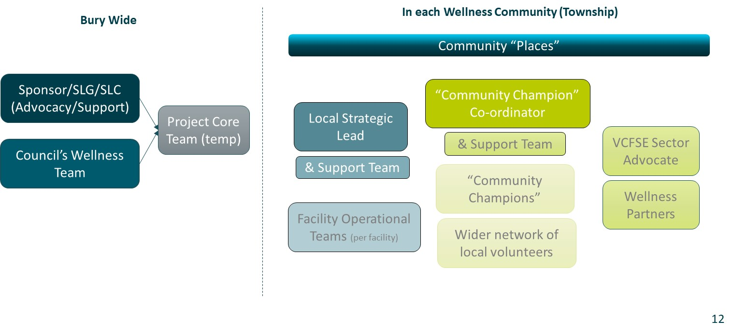

* A delegate highlighted their recent experience of cycling to work – was horrific due to poor surface on cycle lanes. Made her consider how to get investment streams to align (e.g. comms, infrastructure, initiatives etc) to give seamless positive experience to residents.
* Importance of speaking to members early to bring them on the journey.
* Importance of Community Engagement and shared examples of work that is ongoing through the Autumn, working with Collaborate Out Loud and the opportunity to tie in with this.
* There is a lot of learning from the **‘I will if you will’** programme and clearly long-term sustainability is vitally important. Some strong foundations still in place upon which to build. Noted different levels of the ecosystem (e.g. comms, infrastructure, delivery, training) and that all are important overall. More continuous, lower-level investment is more valuable for long-term behaviour/culture change than one-off injections of cash.
* This is proposing a significant piece of reform and is the first articulation of the Let’s do it strategy. The council has a key role as a facilitator/enabler rather than deliverer.
* Also noted need to invest in capacity in the voluntary sector, support for volunteering and workforce development.
* Opportunity to include active travel within the strategy and link to reduced carbon emissions and improvement in air quality.
* Seek to link elected Members’ key concerns to interventions (e.g. plogging), litter picking, food growing, fly tipping to the Wellness Model.
* For those who don’t like ‘exercise’ the messaging may not even be about ‘moving’ (e.g. gardening)
* Look to design an organisational structure that can leverage in additional external funding and commissioning funding from Health etc.
* Don’t always need people to put money into our funding pot; instead can show how this can galvanise alignment of funding towards a common purpose (e.g. transport funding towards active travel, health funding to build capacity for referral routes in VCFSE sector) – co-investment.
* Need for the Wellness Model to be investable and commissionable.
* Need to ensure this Wellness Strategy influences transport policy, planning policy and housing policy – possible need for some stronger links within these functions to embed wellness. Need to understand that these things take time (e.g. high-quality cycling experience in Cambridge happened over 20 years not 3 years)
* Workplace and workforce wellbeing – opportunity to include work underway for Bury Council to walk the talk and support hybrid working linked to a proactive approach to workforce wellbeing and becoming an exemplar for employers in Bury.
* Opportunity to embed wellness into Bury Council job descriptions.
* Bid sent to UK Shared Prosperity Fund for neighbourhood engagement roles linked to Wellness. Pending.
* Opportunity to enhance the Universal / Targeted models to include a life course element linked to Start well, Live Well which was actioned.

# Case Studies

Examples of wellness in action

## Whittaker Lane Active Practice

Opportunity:

### GPs have regular contact with some of the most vulnerable people in our community, including people with long-term health conditions (LTHCs). Many patients do not meet Chief Medical Officer guidelines for regular physical activity[1], even though they would significantly benefit from even small increases in physical activity.

### To help GPs encourage physical activity to their patients and staff, in 2019 the Royal College of General Practitioners (RCGP) and Sport England launched the Active Practice Charter. The charter supports GP practices to raise awareness of simple changes that people can make to bring more movement into their lives. The introduced an Active Practice Award for practices completing the training and introducing the recommended standards.

What’s happening at Whittaker Lane?:

### Text Description automatically generatedIn 2022 Whittaker Lane Medical Centre achieved Active Practice Status, following the introduction of a range of activities and initiatives for staff and patients. For the community this includes Health and Social Walks, social prescribing referrals to physical activities, information and signposting to local activities.

### A person holding a bicycle Description automatically generated with medium confidenceStaff have been getting involved too with regular Walk and Talk meetings, participation in Parkruns and cycling to work. Some team members have also signed up to the Heaton Pizza Run to raise money for a local charity. To ensure everyone can get involved, people have been supported to sign up for different distances from 2k to 10k!

**How is it going?:**

“This is all very encouraging for all staff at the practice. Don’t get me wrong we have some members that are not active. However, even those of us that aren’t, we are always there to encourage on the side-lines of all these events building team spirits as we do. “

**Dr Emma Pimlott, GP and Clinical Lecturer at University of Manchester**

### Many of the activities are relatively new so the long-term impact on staff and patients is yet to be fully seen and measured. Feedback from staff so far though is very positive, and having staff involved in so many initiatives is helping to maintain momentum behind the Active Practice agenda.

### The Whittaker Lane Walks are by far the most established element of the work to date, with strong links to social prescribing across the area. Here the impact is clear, with many patients from both Whittaker Lane and other nearby practices using the walks as a gateway into wider physical activity. Social Prescriber, Julie Bentley, told us:

### "People know where the surgery is which makes it easier for them to join in, breaking down barriers around 'how will I get there'. People are met outside by faces they recognise. Staff from the practice come outside before the walk and have also joined some walks making people feel the surgery is part of their community. The walk offers an easy way for people to become more active with no one being left behind, and it gives an opportunity to talk about other activities people can join in with. In some cases they go along with people they met on the walk. It's a great starting point for anyone wanting to become more active but concerned about joining established exercise walks, classes, gyms.

The social aspect of the walk gets people talking and offering each other support from their own experience making people feel less lonely and benefitting their overall wellbeing."

“I kept being told to join a gym, lose weight and had no idea where to start. I was referred to Julie for social prescribing and we had a plan for me to get more active starting with Whittaker Lane Walks where I could meet with Julie so I know someone. I join the walk nearly every month now and I’m going to go to Prestwich Plodders because I’ve met someone on the Whittaker Lane Walk who goes and will meet me there. Whittaker Lane Walks is a great starting point for anyone trying to get more active” **Participant, Prestwich**

“I’m so amazed at myself, first I thought I wouldn’t have the confidence to join the walk and would just go home, then I thought I wouldn’t have coffee because I didn’t feel confident ordering it or sitting with a group of people chatting but I did it all and loved it. Thank you so much for the warm welcome and support” **Participant 2, Prestwich**

What next?

### Activities are continuing to evolve and there is even an exercise bike in the waiting room being planned. There are also plans for more walks, potentially starting from other Practices in the area to offer variety and ensure people across the ward feel they can access these. There is huge potential for the role of Active Practices across Bury as something which is both doable and can rapidly make a difference for communities, particularly some of our most vulnerable residents.

## Bury Health Improvement Fund

Opportunity:

### Community engagement often tells us that what would most help people build more physical activity into their day-to-day lives is accessible, social, informal and enjoyable opportunities on their own doorsteps. These can often be part of wider activities such as community picnics, wellness classes, or community clean-up projects.

### Generally, the people best placed to deliver such activities are communities themselves, whether that’s small community enterprises, groups of volunteers, or even a group of mates who want to get something going in their neighbourhood. However, these types of groups don’t always fit with the requirements of traditional funding structures, which often require constitutions, financial records, policies and much more.

“We want to make the borough as best it can be and it starts with the community really. So whatever they do is amazing “

**Fay Robson, Locality Officer, Bury Council**

### Finding a way to get funding, resources and support to groups like this, in the heart of communities and engaging with people every day, can be game changing in reaching audiences that would never go to a leisure centre, sports club, or exercise studio.

How did the Bury Health Improvement Fund (HIF) address this?:

### HIF was launched in 2021, offering grants of £5-20k, to support community recovery from the Covid-19 pandemic.

* encourage and support people to make healthier choices and lead healthy lifestyles;
* enable as many people as possible to get 'out and about' walking and exercising;
* inspire people to enjoy the outdoors and Bury's green and open spaces;
* bring communities together and support positive mental health and wellbeing;
* support Bury people to recover from the longer-term effects of Covid; or
* reduce inequalities and support communities and groups hardest hit by the pandemic.

[HIF Summary Film](https://vimeo.com/744135873/bae9d885e0)

### Funding was open to charities, social enterprises, and community groups, including schools, clubs, and voluntary groups. The application process was intentionally quick and straightforward.

### Where groups didn’t meet the basic requirements (e.g. having a bank account), they were supported by Bury Council to work with an umbrella organisation, such as Friends of Clarence Park, who could receive funding on their behalf and provide support and infrastructure to enable the bid. Project Officers also went the extra mile to support on things like marketing, IT, and booking agreements, to ensure bureaucracy or technical issues didn’t hinder success. This support meant many groups who had never received funding before were able to benefit.

How is it going?:

### Radcliffe Sonics Women's Walking Football Group in matching blue hoodiesOver, 12,000 people have engaged with projects, including almost 4000 from the most deprived areas of Bury. 68 out of 114 projects specifically aimed to increase physical activity levels. These include gardening projects, walk and talk groups, outdoor family activities and community litter picking.

**Image: Radcliffe Women’s Walking Football**

### More important than stats however are the countless personal stories of how people’s lives have been genuinely changed for the better. It is hard to single specific projects out when so many positive outcomes have been seen, however, two projects which really emphasise the value of a fund like this are Radcliffe Sonics and Living Life to the Full.

**Living Life to the Full - Men’s Exercise Class (Age UK Bury)**

Living Life to the Full is a course offered to older people to help them get the most out of life when things begin to change as they get older. For example, following retirement, a change in health status, or loss of a loved one. The course helps people to grow in confidence and expand their range of social and wellbeing activities.

One thing identified by participants as lacking in the local communities around East Bury was exercise classes suitable for older men. We often hear discussion of women feeling self-conscious in gyms or more traditional exercise environments, but this can also be a major barrier for men when they are not feeling confident. The men’s only exercise class has since been established and is hugely popular with local men over 60.

**“They say they really enjoy it. They say it keeps them feeling young, they enjoy the company, and it’s a bit of a challenge for them.” Michelle, Project Lead.**

It has even been possible to charge a small fee for the sessions and this now means the class is self-sustaining beyond the HIF investment.

**Radcliffe Sonics Women’s Over 40s Walking Football**

This group was set up in response to local demand from a group of women who were struggling and felt left behind in their community. Many of the women lacked confidence prior to joining this session, had challenges with their mental health, and were experiencing social isolation.

The group runs weekly sessions outdoors and sees strong turn outs every week, regardless of the weather. The girls who take part have become so much more than teammates, they have become genuine friends who spend time together and support each other both within and outside of the football sessions. Physical fitness has also increased as a result of regular attendance.

**“I think the lack of pressure with it being a walking group has really boosted confidence. Individuals who started with the team walking have increased their fitness, I even find them running for the ball sometimes – even though they are not allowed!” Project Lead**

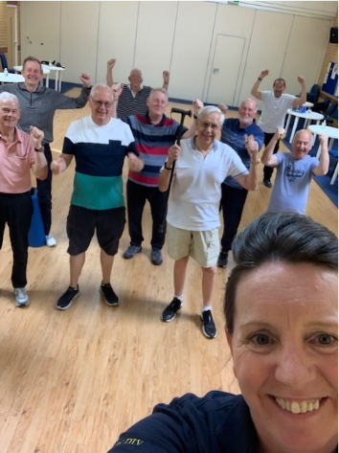What next?

### Sustainability has been at the forefront of every project throughout, with council officers working closely with each group to plan what’s next and ensure this isn’t just a flash in the pan. This has meant a wide range of different support, tailored to the needs of each group, for example, groups have been helped to:

* identify and apply for further funding;
* recruit more volunteers;
* negotiate on room hire fees;
* agree small fees, when possible, to provide additional income without excluding vulnerable residents;
* build long-term relationships with Bury VCFA, who can support them in the future.

### Officers have also hosted volunteer open days and networking events and provided training on process elements, such as navigating funding applications and setting up social media accounts.

**Image: Men’s Only Exercise Group**

### Working with community groups in this way has shown the value of investing resource in this type of small grants initiative. The wrap-around support enables groups to thrive and adds real value to people’s lives. This demonstrates that a long-term investment in a Bury microfunding initiative would be hugely powerful and reach many of those who would benefit most.

“These groups absolutely gave people a reason to leave the house, make friends, learn new skills and make their world big again.  It has been an amazing process to see the growth of the groups and the benefit to people’s lives.  The council should absolutely keep this process alive. Having locality officers that were immersed within each area to keep the groups on track was so beneficial, as the groups felt we were with them every step of the way.

This is the perfect way of the council supporting and not doing for the community – the community have the skills, the people, the assets and the knowledge to know what is needed, they just need funding and support to move in the direction they need most.”

**Shelley Caulfield, Project Lead – Wellness Operations, Bury Council**

## Learning from our Neighbours: Rossendale

Background

### Rossendale is the most south-westerly borough in Lancashire and directly borders Bury to the north. As such it is one of our nearest neighbours and many residents traverse the border between the two as part of their daily lives.

### A group of people walking on a path in a grassy area Description automatically generated with medium confidenceAlthough operating on a small budget, Rossendale have been working hard on their physical activity offer in partnership with the community over the last decade. This has been enhanced since 2018 when Rossendale became one of six boroughs making up the Pennine Lancashire Local Delivery Pilot (LDP), Together an Active Future.

### As we know in Bury from being part of the GM Moving LDP, the pilots enable a test and learn approach. This means a healthy mix of success and failure is accepted, and we learn and improve at every step how to best support and enable our communities. Ken Masser, CEO of Rossendale Leisure Trust (RLT) has been a central figure in pilot activity in Rossendale and shared some key learnings which reinforce our own experience and learnings here in Bury.

Image: Residents Walking

Key Areas of Shared Learning

* **Place-focused**: A focus on working closely with our residents in each township across Bury is a key pillar of the new Wellness Approach. In Rossendale, they too have found this to be a critical component of everything they do. The focus of work is always on what is right for Rossendale, and never on what is right for any individual organisation of business. From a leisure perspective, this is something RLT live by too and, although it may sometimes cost them in the short-term, they have found it pays dividends in the long term.
* **Marketing**: To capitalise on the Place-focus, it is crucial to be visible with the public, partners and funders, about what we are doing, with who, for what reason, and what difference it is making. Our business case includes an ask to increase marketing support to ensure this can be done right. In Rossendale, they would agree, and in spite of very slim margins, they continue to prioritise investment in marketing capability to ensure their messages reach those who need to see it.
* A group of people sitting in a room

  Description automatically generated with low confidence**Cross-sector partnerships**: Our Wellness Model will strengthen the many relationships which exist across Bury between public, private and third sector organisations. Bury VCFA are a central pillar in this and they, along with the many community organisations they support, are often better placed to engage the communities we as a council most want to support.

Image: Community Engagement

* In Rossendale, they have similarly capitalised on partnering, but they do not have the benefit of a CVS. Instead, Rossendale Connected emerged from the LDP in 2019 as a partner collaborative using physical activity to support improved health and wellbeing outcomes.
* The growth of the collaborative was significantly accelerated by the Covid-19 pandemic. Coming together around an urgent common purpose enabled partners to see that, whilst they may have differences in what they do, they all shared a common aim – to support and improve their community.
* Even as the pandemic has subsided, this energy has been maintained and invested into local collaborations, including new wellbeing programmes such as Walk Rossendale.
* In the absence of a CVS, RLT have stepped in to play a key role as facilitator for Rossendale Connected. In some ways, however, the lack of an obvious leader has been empowering to group members, with local organisations stepping up to take responsibility with an attitude of ‘if not me then who?’

*“Rossendale Connected has really broken down barriers and as Mr Mannan said tipped the pyramid on its head with a very grass roots response which valued everything and everyone within our community”* ***Helen Jeeves***

*It’s so lovely to be connected to a wonderful group of like-minded people who care about each other and Rossendale. I feel proud to live and work here”* ***Lorna Robinson***

### Building trusting relationships: Trust has been at the heart of much of the work in Rossendale, not just between partner organisations, but with communities too. Back in 2012, trust was sorely lacking, with the council seeing leisure as a drain on resources and providers feeling the council were underinvesting and not prioritising the role that physical activity and sport could play in local communities. Times have changed dramatically, with RLT now a trusted partner for the council with a high level of autonomy and freedom to operate in whatever way will best serve community needs. Effective local marketing and frequent community engagement has also helped to promote the Rossendale first mentality, meaning residents see local leisure services and assets as their own, and as part of the fabric of Rossendale. This meant during the pandemic that over £200k was raised in member donations to RLT, preventing them from making a loss in such an unprecedented time. Even when a new, high-spec gym opened in Rossendale, council facilities were able to retain the majority of its members who buy-in to the ethos of how they operate.

### Bringing the workforce on the journey: In Bury we already have a wealth of fantastic people doing excellent work to spread the health benefits of an active lifestyle. However, our new Wellness Approach will drive more joined up working and a consistency of experience for our residents, wherever they access the system. To achieve this we know we need to bring everyone on the journey, through inclusion, training and development, and empowerment.

### Rossendale too invest heavily in embedding their ethos in the workforce at every level to ensure a positive experience, regardless of whether you are engaging with a senior manager, a receptionist, or walk leader. Budgets have sadly not allowed them to reward staff with large salaries, but being part of something that benefits the community, alongside other staff benefits like family access to leisure service, has kept staff turnover low, even when similar roles in neighbouring boroughs have offered greater financial reward.

### Ken Masser acknowledged that this comes with risks too, not least that it makes it challenging to offer career progression with turnover so low; but they know they must strive to keep the day-to-day challenge fresh and to distribute institutional knowledge in order to mitigate against the loss of key figures and relationships.

#### Looking to the Future

### Right now, like everyone, Rossendale are looking to weather the storm of the current cost of living crisis. However, the strong relationship with the council means they are willing to back leisure services financially to come through this period of uncertainty.

### A group of people in a room Description automatically generated with low confidenceBeyond that, Rossendale’s aspirations hold many similarities with our own in Bury. Aged buildings are increasingly a drain on resources and no longer fit to serve communities in the way that is needed. Like us, they know that investment in large scale facility development is both unlikely and probably not the best way to serve our communities, who want low-cost, locally run, social and informal opportunities for physical activity in the communities where they live and work.

Image: Multipurpose Community Space

### A model is being proposed for a series of community hubs across Rossendale, with a number of micro‑facilities, to include small scale swimming, exercise and multipurpose community spaces. This will not only enable more people to access these spaces, and take part in diverse activities which are suited to their needs and abilities, it will also enable growth of the physical activity health offer and provide an opportunity for Proportionate Universalism within the pricing model.

### RLT already offer weight management services, cardiac rehab, exercise on prescription and health coaching, in partnership with the local NHS. New investment would create space to not only extend these services, but create new opportunities for things like falls prevention and long covid support.

### It is a moment in time when budgets are tighter than they have ever been, however, like in Bury, it is also a moment when short-term investment is essential to pay long-term dividends for communities.

## Goshen Sports Club/Bury Football Foundation

Opportunity:

### Creating accessible and high-quality places for local clubs to operate and flourish is a key component of creating local access to physical activity and recreational opportunities for young people and their families.

### The investment into Goshen Sports Club to establish high quality facilities for all its users is a result of effective partnership working with the Council and the freedom given to the Bury Football Foundation and the other Clubs to ‘get on with it’.

“Our independence enables us to support grassroots football for all sections of the community and this is at the heart of our philosophy”

**Mike Morris, Bury Football Foundation**

### The community-oriented approach championed by The Bury Football Foundation (which operates independently of any professional or semi professional club) enables it to focus on equality of opportunity and grassroots development through the 35 teams that operate on the site.

What’s happening at Goshen Sports Club?:

### Bury Football Foundation operates a unique community based Charity supporting grassroots football development in Bury. It the largest Football Charity and operates out of Goshen Sports Centre, home to Bury Football Foundation (who operate the football facilities alongside a strategic partnership with [Bury FC Foundation Grassroots Football Club](https://www.buryfcfoundation.co.uk/) ), [Bury Gymnastics Club](https://www.burygymnastics.org/), [Bury Cycle Speedway Club](http://www.burycyclespeedway.com/) and [Bury Metro Radio Controlled Car Club](https://www.bmrcc.co.uk/).

**Image: 4G Opening Ceremony**

### A group of people standing on a field with a ball Description automatically generated with low confidenceThe football facilities include 10 high quality x grass football pitches and a new 4G floodlit football pitch, plus offices that the charity have renovated via other grant funding. The gymnastics facilities include an indoor gymnastics fa facility, dedicated model car track area and cycle speedway track supported by parking and related infrastructure.

### Bury Football Foundation seek to operate/facilitate a full year-round programme of education programmes, training, coaching and pitch hires to support community football and its football partners. Under a longstanding strategic partnership structure, Bury Football Foundation alongside Bury FC Foundation football club (grassroots) cater for walking football teams, disabled football, men’s teams, men’s and women’s veteran’s teams along with a Wildcats Wildcats girls (6-11) group football programme, as well as of course multiple teams for both boys and girls at ALL age groups. This structure ensures that the site benefits from Charitable status and the also the highest level of FA Charter Standard club benefits.

**Image: Bury FC Foundation**

### A picture containing grass, outdoor, sky, tree Description automatically generatedAs an example of community partnership working, Bury Football Foundation work closely with Bury School Games who look after competitions for Primary Schools across the borough. This currently sees Bury Football Foundation providing free access to the 4G pitch several times a year hosting the inter school competitions for Football but also cross country and a few other sports. Bury Football Foundation also utilizes its strategic relationships with full time education provision on site, to utilize students who in turn volunteer for Bury School games events as match officials and coordinators.

**Image: 4G Pitch - Goshen**

### The Bury Gymnastics Club are located at the Paul Reay Gymnastics Centre in Bury. They coach a wide variety of gymnasts, from pre-school to GB squad members. Their aim is to provide the highest quality of training to children and young adults in a safe and challenging environment. They want to encourage all gymnasts to reach their own goals and achievements appropriate to their abilities. They operate a wide range of affordable classes and opportunities for junior sessions, soft play sessions, adults sessions, badge classes and the formal gymnastics club.

### The Bury Cycle Speedway Club run one of the best in the country, winning praise from many of the world’s best riders.

### Continuous development of the club’s facilities has enabled Bury Cycle Speedway to stage some of the sport’s biggest national and international events in recent years.

### Bury Cycle Speedway has always been well known for its recruitment and training of young riders.  Cycle Speedway’s incorporation into [British Cycling](https://t.umblr.com/redirect?z=https%3A%2F%2Fwww.britishcycling.org.uk&t=YzE1ZmI5MzA4YWU4NjdjNmRmZTdiN2RiZTVhZTM2NTkzOWJhMmU4OSxUbU4zdWpESg%3D%3D&p=&m=0) has only strengthened this policy, with the club achieving [Go Ride status](https://t.umblr.com/redirect?z=https%3A%2F%2Fwww.britishcycling.org.uk%2Fgo-ride&t=ZDI1ZjIzNGQ5ODU4Y2NkYTExODE0YzgzYTRjODhjODQxYzhlZjAxMCxUbU4zdWpESg%3D%3D&p=&m=0) early in the new millennium, before receiving [Clubmark](https://t.umblr.com/redirect?z=http%3A%2F%2Fwww.sportenglandclubmatters.com&t=YjVhMmFkNGY2MjBlOWJiZWM0OTU1MGFlNzgzNjZkMDVhZGE0ODQyNSxUbU4zdWpESg%3D%3D&p=&m=0) accreditation in 2010.

### Statistically as a site approximate breakdown of usage can be found below:

* Bury Football Foundation Av approx weekly usage: 975 participants plus volunteers and parents (Age range 6 – 80) OR 1,325 engagements weekly plus volunteers and parents
* Cycle Speedway Av weekly usage (Cycling)
* Metro Car Club Av weekly usage (Metro) 120 per event (fortnightly)
* Gymnastics Club Av weekly usage 850 participants (Gymnastics)

What next?

### There are significant opportunities for all the clubs at Goshen to work collaboratively to support their individual growth and collective sustainability. The office accommodation could provide a base for Wellness Community team members and activities.

# Wellness Business Model

Designing a flexible, commissionable model to support township based delivery

## Central Support and Leadership

### The Wellness Strategy and supporting model will require a dedicated team that works alongside the current Wellness Team that incorporates services such as facilities operations.

### Looking ahead there will be opportunities to explore combining these together further, linked to further service and facility-based transformation.

### The central function will need Director level leadership and a senior management team with specialisms in:

* Establishing, maintaining and growing strategic partnerships within and across Bury and Greater Manchester - e.g. with GM Active, Greatersport, Bury Local Sport England Pilot VCFA, Youth Service, Education, The ICS, Sports Clubs, Housing and Employment Advisory Services, Age UK Bury etc.
* Developing an insight function using local data sources through partners to support the targeting of support and interventions, linked to monitoring and evaluation function to support funding applications and commissioning
* Developing effective strategies for township / neighbourhood engagement and to support the Wellness Teams in communities
* Marketing and promotion of both the overall approach model and of specific initiatives and activities
* Programme support to coordinate the activity of the 6 Township based teams in engagement, co-production and sharing learning.

### These functions would primarily be new roles created given their specialisms however, there could be some opportunities to use existing functions within Bury to fulfil these functions on either a secondment or part time basis.

### SLC understands that there is likely to be some degree of reorganisation within a number of departments and this could create opportunities to redefine and reassign roles internally. The design of this service will be closely aligned to the Council’s successful Community Hub Model which has played a pivotal role in supporting communities through the Covid pandemic and its aftermath.

### The proposed organisational structure highlighting the functions required centrally to support township / neighbourhood-based working is set out in Table 7 below:

|  |  |  |
| --- | --- | --- |
|  |  |  |
|  |  |  |
|  |  |  |
|  |  |  |
|  |  |  |
|  |  |  |
|  |  |  |
|  |  |  |

## Wellness Community Teams

### The Wellness Community Teams will have two core functions and be focused on the 6 specific townships with greater resources targeted in **Radcliffe** and **Bury East.**

### These will be dedicated full time roles ideally using local community members with established networks and / or experienced neighbourhood-based workers.

### The four core functions at Township / neighbourhood level are as follows:

* Wellness Neighbourhood Lead
* Wellness Neighbourhood Coordinators
* Wellness Coaches
* Exercise Referral Officer

### Building on experience of the Community Hubs these roles will require the following attributes and skills:

* Bring specialist experience to support the wider team and promote best practice – e.g. LTHC management, working with young people, working with ethnically diverse communities, mental health, disabled people etc.
* Identify, connect and build relationships within their Townships’ communities of interest and stakeholders (e.g. Sports Clubs, Schools, Community groups etc)
* Feed in local knowledge, viewpoints, issues and opportunities to the wider team
* Support Wellness Partners at a Township level in enabling physical activity programmes, events and development
* Lead on community engagement to support co-production of wellness activities within their Township
* Support in the co-production of activities bespoke to groups, communities within their Township
* Support marketing & comms of activity, learning and good news stories within their Township
* Apply the Bury Wellness Continuum approach to their work based on: enabling Communities to do things for themselves, enabling communities to do things with support, supporting communities in accessing direct services.
* Recognition and appreciation of volunteers
* Connecting community leaders and stewards to each other
* Providing technical assistance and support to build capacity and leadership.
* Apply five key approaches to supporting communities:
  + - 1. Strengthen community groups and networks
      2. Recognise and celebrate their accomplishments
      3. Access resources
      4. Improve their leadership skills and organisational capacity
      5. Connect with System Partners and Ward Councillors to influence local decisions.

### The design of this service will be closely aligned to the Council’s successful Community Hub Model which has played a pivotal role in supporting communities through the Covid pandemic and its aftermath. It will also be influenced by best practice models, within Bury, GM and wider afield.

#### The proposed organisational structure to support each township / neighbourhood-based working is set out in Table 8:

Table 8 – Job Descriptions

|  |  |  |
| --- | --- | --- |
| Role | **Description of role** | **Grade / Gross salary and on costs** |
| **Wellness Neighbourhood Lead**  1 each in Radcliffe and Bury East  1 covering Tottington, North Manor, Ramsbottom & Bury West  1 covering Whitefield, Unsworth & Prestwich | Strategic leadership for township, including overseeing local approaches and plansPrimary relationship with strategic stakeholders – e.g. ICS, Greatersport, GM Active, Sport England, Local Delivery Pilot, Bury CouncilWellness Strategy Lead for Township inc. driving forward implementation plans and maintaining focus on tackling inequalitiesLead on local community engagementStrengthen community groups and networks, drive collaborationRecognise and celebrate local accomplishmentsIdentify, promote and support opportunities for external fundingDevelop local leadership skills and organisational capacityConnect with System Partners and Ward Councillors to influence local decisions.Support and line management for Wellness Neighbourhood Coordinators, Wellness Coaches and Exercise Referral OfficersShare good practice across other Townships |  |
| **Wellness Neighbourhood Coordinators** 3 each in Radcliffe and Bury East3 covering Tottington, North Manor, Ramsbottom & Bury East3 coveringWhitefield, Unsworth & Prestwich | Be accountable to the Wellness Neighbourhood Lead.Primary relationships with community leaders, community organisations, Comms & Marketing Lead Wellness Coaches, Exercise Referral Officers and other Wellness Neighbourhood LeadsIdentify and connect with leaders in community hubs to ensure communities of interest are understood and represented.Support on local community engagementFeed in local issues and opportunities to the Communications Team and wider leadershipSupport the wider community wellness networkCo-ordinate wider community wellness engagement e.g. establishing resident forumsTake responsibility for understanding issues and needs in a place and responding with the support and materials requiredClose gaps in community wellness relationships and networks |  |
| **Wellness Coaches** 2 each in Radcliffe and Bury East2 covering Tottington, North Manor, Ramsbottom & Bury West2 covering Whitefield, Unsworth & Prestwich | Be accountable to the Wellness Neighbourhood Lead.Primary relationships with clients, community organisations & services, Wellness Neighbourhood Leads, social prescribers, Exercise Referral Officers and other Wellness CoachesIdentify individuals in need of supportBuild and share knowledge for locality on suitable wellness support, activities and other provision to signpost clients and community members to1:1 support for vulnerable clients to assess lifestyle and support them to improve wellbeingProactively build relationships with communities experiencing inequalities and build new clients onboardDevelop & deliver group-based wellness and self-care courses and opportunitiesBuild peer support networks for vulnerable groups in the locality |  |
| **Exercise Referral Officers** 1 each in Radcliffe and Bury East1 covering Tottington, North Manor, Ramsbottom & Bury West1 covering Whitefield, Unsworth & Prestwich | Be accountable to the Wellness Neighbourhood Lead.Primary relationships with clients, community physical activity groups, Wellness Neighbourhood Leads, Wellness Coaches, social prescribers, and other Exercise Referral OfficersFocus on health improvement through physical activity for local community, especially diabetes, pulmonary, musculoskeletal, cardiac and falls prevention1:1 support for vulnerable clients to assess and change lifestyle and increase physical activity for improved health outcomesBuild and manage relationships with referral partners, inc alignment with local GPs and social prescribersIdentify, assess, promote and support development of suitable physical activity programmes to support LTHCs, rehabilitation and deconditioning prevention.Promotion of BEATS and wider physical activity opportunities in local communities, focused on communities experiencing health inequalities and deprivation. |  |

## Township Distribution of Wellness Leads / Coordinators

### The rationale linked to addressing the greatest inequalities results in the Wellness Leads/ Coordinators being proportionately distributed with an initial focus on Radcliffe and East Bury.

### It is likely that after c 3 years, this structure may evolve to have focused Wellness Neighbourhood Teams for each Township or for another priority area outside Radcliffe / Bury East.

## 

## Support Service Functions

### The following support services functions will initially be based around Bury Council providing services (on the assumption the service remains ‘in house’ for the time being.

ICT

* Mobile office functions (mobiles / laptops etc)
* Website / Communications / Social Media

Legal Support

HR

Finance

* Customer Data
* Finance systems
* Customer Payments
* Invoice payments
* Invoices raised
* Financial information
* Payroll
* Monthly salary and wages
* PAYE
* Pensions
* National Insurance.

Transport

Bikes and e bikes.

## Operational Budgets

### The Wellness Service will require an operational budget to cover the following elements:

* Marketing and Communications (Brand / Design / Print etc.)
* Events
* Activity programmes and sessions (fees for leaders and instructors)
* Workforce Training and Development
* Township Wellness Grants Programme
* Fundraising
* Equipment
* Evaluation / Reporting / Digital

## These functions are described in more detail in Table 9.

**Table 9 - Operational Functions**

|  |  |  |
| --- | --- | --- |
|  | **Description** | **Annual Investment** |
| **Marketing and Communications (Brand / Design / Print etc.)** | Budget for development of bespoke Wellness Brands for each Township, printed material for use in community settings, postcards, posters and banners etc. | Radcliffe and Bury East respectively  £25k  Tottington, North Manor, Ramsbottom & Bury West £12.5k  Whitefield, Unsworth & Prestwich £12.5k  **Total £50k** |
| **Events** | Budget for supporting and holding events such as open days, ‘Give it a go’ type events and to support community events.Stakeholder events to support development of the Movement for Movement. | **Total £50k** |
| **Activity programmes and sessions (fees for leaders and instructors)** | Budgets to initiate activities led by qualified instructors / coaches in townships and funding to support local people get qualifications. | **Total £100k**  (60% Radcliffe and Bury East, 40% distributed to other townships years 1-3 |
| **Workforce Training and Development** | Budgets to support workforce training and development linked to systems leadership, community development, insight led programming, every contact counts (Bury Council and System wide) etc. | **Total £30k** |
| **Township Wellness Grants Programme** | Local easy access and low admin grants system overseen by Community Wellness Team and Ward Councillors. | **Total £100k**  (60% Radcliffe and Bury East, 40% distributed to other townships years 1-3 |
| **Fundraising** | Dedicated budget for professional outsourced fundraising support to secure donations from local business and partners. | **Total £25k** |

## Developing an optimal structure within Bury Council and with its strategic partners

### It is recommended that the Council use this opportunity to position the Wellness Strategy optimally within its own corporate structure building on its ambitions for Public Sector Reform.

### The role of Public Health linked to the Wellness Service make it an obvious place for Wellness Services to sit.

### In order to commence building the partnerships with a view to securing pooled budgets and genuine engagement from partners across the system, it is recommended that some Forums are established linked to a Memorandum of Understanding and structure to support pooling of budgets.

### Linking this group through to the Live Well Mayoral Commitment, the Pivot to Wellness and Bury’s own approach to Public Sector reform presents an ideal opportunity for Bury to lead / pivot from the front.

### This would optimise the potential for additional external funding and in-kind support from partners such as Greatersport.

# Digital Transformation Programme

Building on Bury’s Digital Ambition

## Current state position

### Consultation with lead officers – Chief Information and Head of Communications established the current state position of Bury’s Digital Transformation programme which is currently being scoped across the Council – including Leisure.

#### Let’s Do it Once Programme

### This programme is based on a channel shift to support customer contact with a digital first approach.

### Current customer interface is poor and this also applies to leisure in terms of booking and paying for services. Phone contact is still dominant and systems are not as integrated as they should be.

### There is no “customer circle” i.e., a feedback loop for customers to get updates from Council, there remains services that customers have to call and speak to someone.

### There is currently no single overview of the customer, with separate accounts for each service

### A “One Account” is in development and is to be more data led.

### Bury has developed a target operating model based on 7 golden rules and a tired model of engagement ranging from customers doing it for themselves to 1: support dealing with complex issues.

### The new content management system for the website is being tendered following support from Agilisys to scope it. There is an opportunity for Leisure and Wellness to be included within this.

### This is linked to a new website.

* The new website for Bury Council has potential for micro sites (e.g. Leisure / Wellness)
* Focus on meeting the needs of mobile phone users accessing the website (60%)
* It will be a stripped back version based on ‘Book it’, ‘Pay for it’ and ‘Report it’ – less general information
* Leisure operations will need to be integrated into it linked to their new MIS system and future modules as well as new gate access systems linked to customer insight and member tracking also need to be considered.

### The Wellness Strategy was discussed and a type of website interface that was more focused on building a movement and a community, highlighting local events, activities and signposting communities to opportunities.

### In terms of timescales, the inception meeting for the new website development is mid – end September and the new website needs to be in place by December 2022.

### Leisure had been developing copy for the old website system (GOSS) and was informed that this could be ported over to the new one.

### It was agreed that for the present time any website for the Wellness Model needs to sit within the Council website infrastructure.

### The future and role of the Bury Directory was discussed linked to future revisions.

### There was an opportunity to more effectively ‘hoover up’ data within Townships to support insight and local decision making and responsiveness.

### Resource requirements to maintain and update the core site and wellness model was discussed and further follow up would confirm the quantum and grade.

## Emerging Vision for digitisation to support wellness

### There could be some real opportunities to build off the back of GM Moving / GM Pivot opportunities regarding digitisation linked to open source data in the future.

### Similarly there is an opportunity to learn from other GM Operations to support design of the website and digital interface.

### Emerging Wellness Strategy highlighted opportunities linked to Digitisation - e.g.

* Continue to support the development of open data and digitisation of local opportunities to support active lifestyles and improve local insight.
* There is a growing demand for more personalisation through digital offers and some older age groups are still nervous and staying at home.
* Improved digital access to physical activity programmes for home use.
* Using open data to identify greater opportunities for residents and to develop greater insight on users and preferences.
* Opportunity to personalise, and micro personalise an offer to individuals to support behaviour change to a healthier lifestyle.
* Opportunity to develop targeted digital concessions and create a more seamless way of supporting individuals in lifestyle changes.
* Links and opportunities with Social Prescribing
* Radcliffe Civic Hub - opportunities.

# Glossary

## Introduction

### Many of the terms relevant to this work do not have fixed definitions. To ensure clarity and consistency in what we do, and to what aim, we are collating this glossary of key terms.

### Below are the terms which have emerged so far with working definitions. These will be refined and added to with the core project team in response to wider input from key stakeholders throughout development of the business case and beyond.

### **Health:** For this work, the council will use the WHO definition of health.

### "Health is a state of complete physical, mental and social well-being and not merely the absence of disease or infirmity."

### **Wellness:** Is a state of having all the necessary things to achieve good health, in terms of Mental, Physical, Social and Emotional. This includes the necessary things to tackle the social determinants of poor health, including poverty, worklessness, poor housing, and poor educational outcomes.

### **Contributors to Wellness:** Social connectedness, regular physical activity, good nutrition, quality sleep, mindfulness, sense of purpose, feeling safe, absence of unmanageable stress.

### These are aligned to the Five Ways to Wellbeing: Connect, Be Active, Take Notice, Learn and Give

### **Wellness Approach:** Adopting a whole system approach across Bury to enable a connected network of community-led, flexible opportunities for the wellness of residents to be supported.

### **Physical Activity and Culture to support the Wellness Approach:** Uses physical activity and culture in any way which is effective to support the factors which contribute to wellness (above and beyond providing regular opportunities for physical activity and culture). This is the focus of the current business case.

### **Pivot from Leisure to Wellness:** This phrase is used when describing how the leisure, physical activity, culture and sport sector is repositioning itself to support Wellness, as its main aim, as oppose to leisure, physical activity, culture and sport for its own sake.

### **Physical Activity and Culture for Wellness Community [or Wellness Community**]: Under the proposed new approach, each of the 6 townships will become a Wellness Community, with its own network or ecosystem of people, “places” and activities, supported by local Wellness Partners contributing to the whole system approach.

### **Physical Activity and Culture for Wellness Partner [or Wellness Partner]:** Any organisation or individual that contributes to the Wellness Approach.

### **Physical Activity and Culture for Wellness “Place” * [or Wellness “Place”]:** Any place within each Wellbeing Community which is a centre for community wellness activity, as defined by that community. This might be a park, a community centre, a walking or cycling track, a market place, a leisure venue, a street, a housing estate or anywhere else that brings people together for wellness activity.

### **“Community Champions”** * A network of volunteers, supported by Wellness Partners and “Community Champion” Co-ordinators, who promote, encourage, and galvanise the people of their community towards wellness activities.

### **“Community Champion” Co-ordinators** [NAME TO BE IN LINE WITH ABOVE]: A person within each township responsible for the recruitment, training, support and day to day management of the Community Champions in their area.

### **Physical Activity and Culture for Wellness Asset [or Wellness Asset]:** collective term for all the elements that make up a Wellness Community – Partners, “Places”, skills, activities – aligned to Asset-based Community Development (ABCD)

#### * Suggested Alternative Language:

### **Place:** Hub, Centre, Hive, Exchange, Meetup, Hangout

### **Community:** Local, Neighbourhood, Township, Bury, Active

### **Champion:** Placemaker, Playmaker, Activist, Connector, Activator, Mover, Spark Plugs (GM)

|  |
| --- |
|  |



|  |  |
| --- | --- |
| **Bury Council**  **Head office**  The Sport, Leisure and Culture Consultancy  Freshmill, Delta House, 16 Bridge Road Haywards Heath, West Sussex, RH16 1BY,  United Kingdom  01444 459927  info@slc.uk.com  **www.slc.uk.com**  September 2022 | |
|  |  |

|  |  |
| --- | --- |
| SLC was established in 2009.  Working alongside core cities, metropolitan councils, borough and district councils, we support active communities. |  |

1. [UK Chief Medical Officers' Physical Activity Guidelines (publishing.service.gov.uk)](https://assets.publishing.service.gov.uk/government/uploads/system/uploads/attachment_data/file/832868/uk-chief-medical-officers-physical-activity-guidelines.pdf)